Health and Wellbeing

At St Julie Catholic Primary School, we aim to promote positive mental health and wellbeing for our whole school community and recognise how important mental health and emotional wellbeing is to our lives. We acknowledge and understand that children’s mental health is a crucial factor in their overall emotional wellbeing and can affect their learning and achievement at school. Our personal mental health and emotional wellbeing is a universal, significant and powerful feature of who we are as human beings - it is an indicator of social, emotional and physical wellness. Young people’s happiness, life satisfaction and positive functioning are influenced by mental health and emotional wellbeing. Good mental health and emotional wellbeing allows individuals to learn, grow and develop as individuals – it is an integral and essential aspect of human life to ensure that young people can make the most of their unique potential, flourish and show resilience when they face any challenges in life.
The Department for Education (DfE) recognises that, ‘in order to help their children to succeed; schools have a role to play in supporting them to be resilient and mentally healthy.’ Schools can create a nurturing and supportive environment for young people to ensure that they reach their full potential; develop their self-esteem; overcome adversity and build their resilience.
Our role, in school, is to encourage positive mental health and emotional wellbeing and ensure that our children are equipped with the necessary skills to manage their feelings, emotions and any experiences that they may face in life. Furthermore, our aim is to help develop protective factors, and build resilience, in a school where:
- All children are valued
- All children have a sense of belonging and feel safe
- All children feel able to talk openly, to a trusted adult, about their mental health and emotional wellbeing
- All children feel that positive mental health and emotional wellbeing is promoted and valued
At St Julie Catholic Primary School, we are passionate about making a difference to the lives of young people. We believe in working together, as a community, team and family. We act with determination. Whatever issues our students, their families, the school, our team or the community face, we always support each other, react compassionately and pull together.

To continue promoting health and wellbeing, St Julies is taking part in the Wellbeing Award for Schools (WAS) information about the award is below

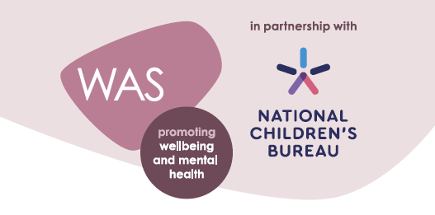

The Wellbeing Award is developed in partnership with the National Children’s Bureau (NCB), the award is intended to help schools prepare and equip themselves to promote emotional wellbeing and positive mental health across the whole-school community. NCB’s vision is an education system where good emotional wellbeing and mental health are at the heart of the culture and ethos of all schools, so that pupils, with the support of their teachers, can build confidence and flourish. Evidence shows us that wellbeing is of central importance to learning and attainment, with high levels of wellbeing associated with improved academic outcomes. Conversely, pupils who have mental health problems are more likely to have academic difficulties at school and experience social disadvantage later in adult life.
To achieve this vision of wellbeing at the heart of learning, NCB advocates the use of a ‘whole-school approach’ where all aspects of the school experience are harnessed to promote the emotional wellbeing and mental health of pupils and staff. It is an approach where emotional wellbeing and mental health is everybody’s business.
In order to evaluate our current provision, we need your input. Your views are important in helping us understand what we are doing well and how we can do even better.
Please follow the link below to complete the survey. All responses and suggestions will be carefully considered and used to plan a range of school improvements.
Evaluation submissions are valid between: 04/11/2022 - 18/11/2022. Your submission will not be accepted outside of these dates
https://app.awardplace.co.uk/stakeholder-evaluations/user-survey/63614ebeca897
Thank you for your continued support
Mrs Slocombe

