St Julie Catholic Primary School Wellbeing and Mental Health Information

Wellbeing days  In school we have lots of wellbeing and mental health days so we can talk about our feelings and emotions.  We talk about mental health during assemblies, and we know we can always find a trusted adult in school to discuss any issues. For mental health day we came into school wearing green and during the day we took part in mindful activities, outdoor learning and talked about our feelings and emotions.  For anti-bullying week we also focused on Random Acts of Kindness. We enjoyed making drinks and treats for our teachers, completing acts of kindness for our friends. When Year 3 visited Eccleston Library they spent mindful moments creating inspiring bookmarks with positive words written from them to the lucky person who will find them in their book  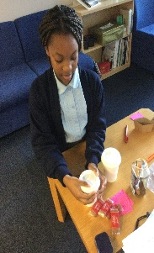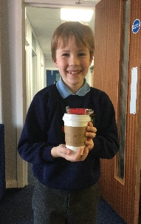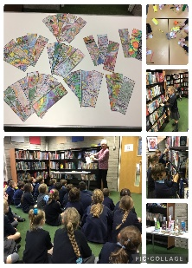 | Zones of Regulation  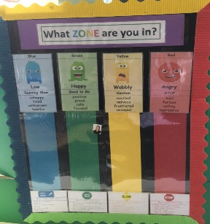  Every class has a Zone of Regulation chart, a sensory box filled with fidget toys and a calm down area, where children can ‘self-regulate’ and have time to think about their emotions.  We use Zones of Regulation at our school so that we know if your child is in need of support or is not having a great day.  When you come into class in the morning time you think about how you are feeling and place your face either in the blue zone, green zone, yellow zone, or red zone. If you are feeling blue, red, or yellow a teacher will support you and ask, “how are you feeling?” You might feel different emotions throughout the school day  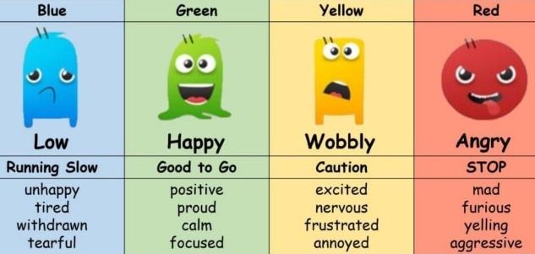 | Rainbows and Worry Boxes  Rainbows supports self-esteem, trust, confidence, and resilience, whilst promoting positive emotional development and healthy relationships  Rainbows is a group where you can talk about feelings and emotions. Sometimes you may feel very sad and have lots of worries, so going to talk to Mrs Owen (the rainbow lead) will help.  Our Key Stage 2 children said:  "Rainbows makes me feel calm and thankful. It is a nice experience for me."  "It makes me feel more confident. Sometimes it's nice to talk to someone."  In each class we also have worry boxes which we can write a little note and an adult is always around for us to talk too  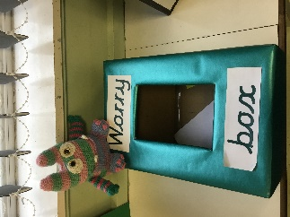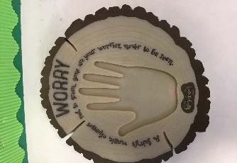
Playground Buddies and Wellbeing Ambassadors  As a team we decided on things that we will do:  - Spread happiness and peace throughout the school.  - Welcome new children and staff to the school.  - Be kind, caring and helpful towards others.  - Always treat others as you would like to be treated yourself.  - Promote and put into place the 'Six Core Values'. ( Respect, Unity, Resilience, Love, Hope and Honesty )  - Always walk in the Footsteps of Jesus’  We meet with Mrs Ashcroft to discuss how we can ensure everyone is happy in our school  Playground buddies support younger children on the yard during lunchtime by playing a variety of games such as ‘What’s the time Mr Wolf?’ Buddying is important because you meet new people and make new friends. If someone is feeling lonely or a bit sad you can talk to them and make them feel happy.  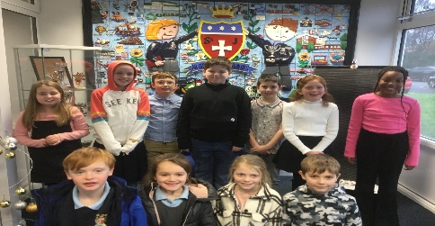 | Outdoor Learning  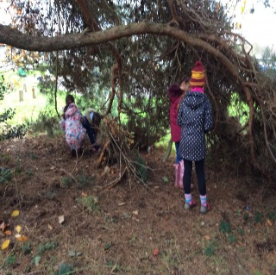  Every term each class has a Forest School Day and we come to school in our own clothes and spend all day outside  Forest school days are so much fun, and it is really important that we spend time outside and enjoy nature.  During forest school we have to work as a team and collect natural materials, make dens, explore the forest, and create artwork.  My favourite part of forest school is lighting the fire and toasting marshmallows and putting them with cookies to make delicious ‘smores’  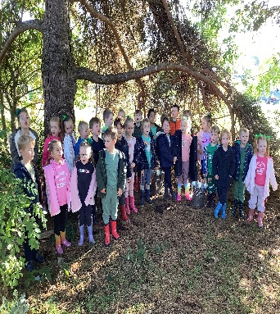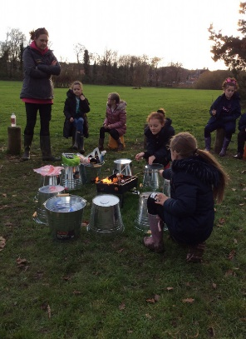 | Trips and visitors  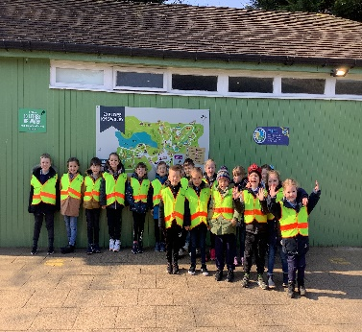  We get to go on lots of fun school trips with our friends we also have lots of visitors who come into school  In KS1/EYFS you go on lots of exciting trips to Build a Bear, the Toy Museum. Southport Eco Centre. My favourite trip was when we went to the Safari Park and saw the huge tigers.  In KS2 the teachers plan trips to Chester, Jodrell Bank, the Theatre, the Philharmonic. My favourite trip was Kingswood, when we went on a huge zip wire.  We also have lots of visitors into school such as authors and poets.  Our school gets to go on so many fantastic sporting events such as rugby, dance, boccia, football, multi-skills, athletics, gymnastics and so many more. In Year 6 we get to go on a brilliant residential experience.  