



All About:

Jayne

I take care of myself by:

* Singing very loudly (and badly)
* Eating chocolate
* Reading a good book
* Retail therapy

My favourite quote is: 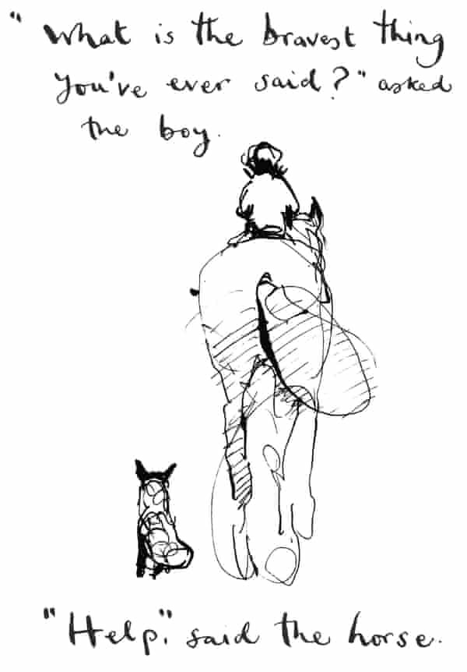

*“*

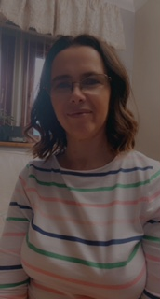

*My favourite food is:*

*Shepherds Pie*

*I am an Educational Mental Health Practitioner*