Spring Term Newsletter
At St Julie’s we have taken up the challenge to, 'Live Simply' and are working towards gaining the CAFOD Live Simply Award for our school.
The award is all about protecting our planet and the people on it. It is given to communities who can show how they:
- live simply
- live sustainably with creation.
- live in solidarity with people in poverty.
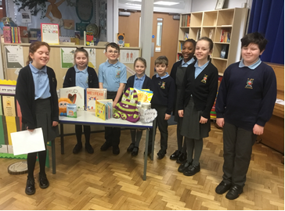
Live Simply
We consider our mental wellbeing an essential part of our Live Simply philosophy. This term we held a coffee morning to introduce parents to Jayne Aspinall, our new Education Mental Health Practitioner (EMHP). Our Wellbeing Ambassadors started the event held at the start of Children’s Mental Health Awareness week by talking to everyone about what we already do at St Julie’s to look after our wellbeing and our own mental health. They demonstrated how the Zones of Regulation are used every morning as they come into class and showed the books and stories we read, and the Worry Jar or box in every classroom.
Children enjoyed a day dressing to express themselves and were able to share ideas in assembly about how they look after their mental health and how they can help others around them.
We have taken time in our busy lives to ‘Live Simply’.
- During Lent, KS2 classes and their families have taken time after school to spend half an hour before the Blessed Sacrament in Eucharistic Adoration.
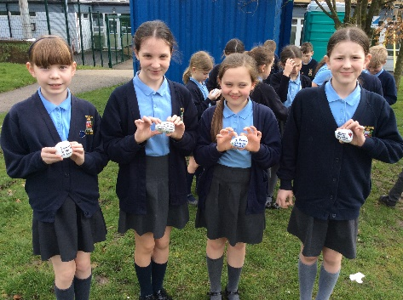
- The Easter Passion service, led by Y5 and Y6, provided another opportunity to take some time out of our busy routines and reflect on our Easter journey. This special time was shared with our school family and parents.
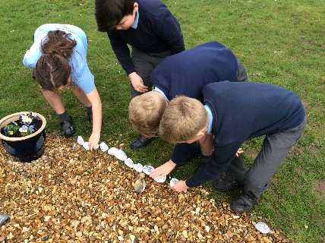
- Y5 and Y6 have also taken the opportunity of Lent to revisit their Live Simply pledge. They have written their pledges on pebbles and placed them in the prayer garden.
- Forest School remains an important part of our curriculum, when pupils and staff can take time to appreciate the awe and wonder of creation. Taking part in the RSPB Big Schools Birdwatch gave us the opportunity to spend time observing nature around our school in the beautiful grounds with which we are blessed.
Live sustainably
Care for our environment has a high profile as we try to live the Pope’s message of Laudato Si’- care for our common home, the Earth.
Y5 enjoyed participating in a ‘Mad Science’ workshop, exploring the use of alternative fuels.
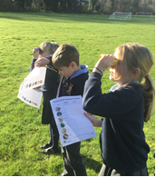
The RSPB Big Bird Watch was an exciting day when classes took turns to observe and note birds in the school grounds. Our observations were forwarded to the RSPB as part of a national weekend of observation monitoring the nations bird population.
We continue to promote a range of recycling initiatives these have included:
- Pre-loved uniform exchange
- Parent book swap (in foyer)
- Children book swap, celebrating World Book Day
Sports ambassadors took time during assembly to remind us that we can walk! We do not always need transport for a journey. This message was reinforced later in the term when the whole school celebrated our ‘Big Walk and Wheel Week’, when we made an extra effort to find alternative means of getting to school without using fossil fuels. This initiative is encouraged every week through our ‘Living Streets’ project “Walk Once a Week.”
Live in solidarity
Our wonderful Y6 Buddies continue to support children around school at break times, helping the infants with their games and being a friend to all.
The residents of Eccleston Court Nursing home remain our friends, being remembered in our prayers and at special times. Y6 have sent cards to the home to wish all a very Happy Easter.
School ambassadors help support our teachers and pupils in all areas of our learning. Reading ambassadors did a wonderful job this term helping our younger children enjoy the ‘Share a Story’ afternoons with parents and carers and in organising events for World Book day.
Faith in Action Award The Chaplain from De La Salle, Sam, came back to Year 6 to spend the day with them as they gathered evidence towards achieving their Faith In Action award. They discussed how during the year they have taken steps to develop their own wellbeing and also how they have supported the wellbeing of others around them, both in and out of school. The children reflected on all the activities they have done to help out in the local community and in fundraising for local and global charities. Year 6 were amazed by how much they have done and that they are well on the way to completing the faith In Action Award. Well done, Year 6!
This term, our charity support has focused on local groups:
Nugent Care: ‘Good Shepherd’ supports those in need across Merseyside. Over Lent each class has taken up the challenge to raise funds for Good Shepherd. Each class chose their own way of raising money which included film afternoons, bingo and board games. The amount raised was £258.30
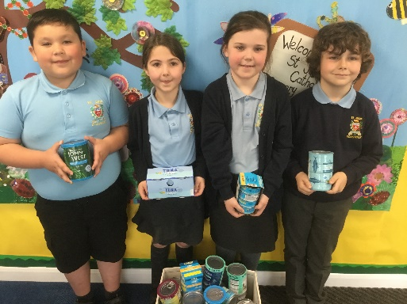
Tuna Tuesday’ during Lent has contributed to a fantastic haul for the St Helens local charity, ‘Our Warm Welcome’, providing food for those in need. Some of our Minnie Vinnies are pictured with the donations ready to be collected.
In our journey through school life we continue to live in solidarity with our schoolmates, celebrating their success through award assemblies and celebrating their achievements.
You can see the many ways that your children are already achieving our aim to Live Simply but there is still much more that we plan to do in 2023.
Our school website has more information about the award on the RE tab under the heading “Living our faith.” In this newsletter we will share with you our many actions this term.
If you have any suggestions or would like to share with us how you Live Simply at home, please email stjulies@sthelens.org.uk with the subject Live Simply.
I will send you a further newsletter in the Summer term.
Thank you for your support,
Mrs Hodgson.

