St Julie Catholic Primary School Reading Newsletter Spring 2023
Produced by our Reading Ambassadors
Welcome to the first edition of our reading newsletter!  We love reading at St Julie’s and value every  member of our school as readers. We would like to  celebrate and share the brilliant reading experiences  we have had across the whole school this Spring term. | Children learn 4,000  to 12,000 words  per year through reading
What reading for pleasure means for us:  Reading Ambassadors  Year 6  We love reading because it gives us a chance to switch off and enter the world we are reading about. When we read, we can imagine the characters we are reading about and, in our minds, we imagine the settings. In our class, we have a relaxing reading area and a variety of different books.  Year 5  Reading gives you the opportunity to experience the world through another person’s eyes. It lets you into other worlds and can prepare you for other experiences. Reading can be tranquil and calming. We have a comfy couch in our reading area, and we can sit back and read fiction, non-fiction, and poetry books. | Books our Reading Ambassadors think you should look out for in our:
 | EYFS/KS1 Library  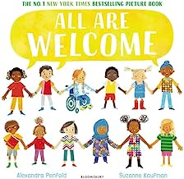  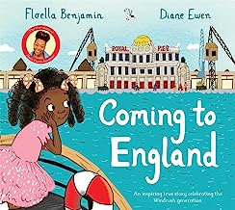 |  | KS2 Library  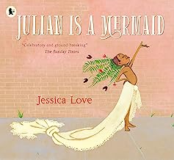  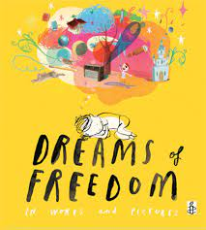
Books we have been enjoying together in class this term

EYFS  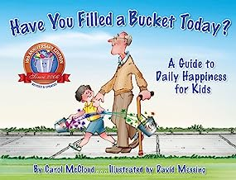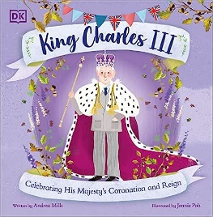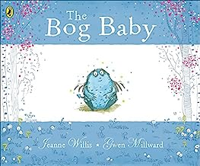 | Year 1  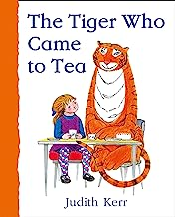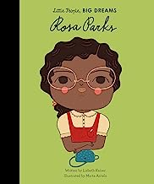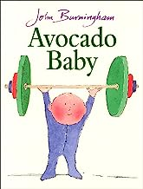
Year 2  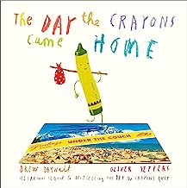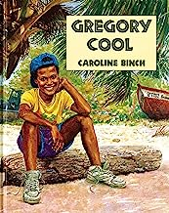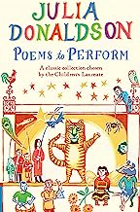 | Year 3  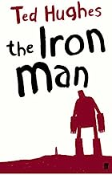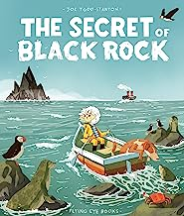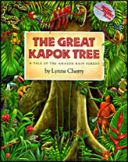
Year 4  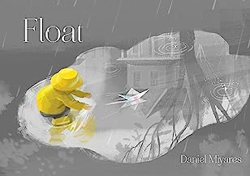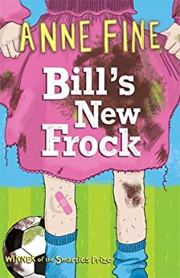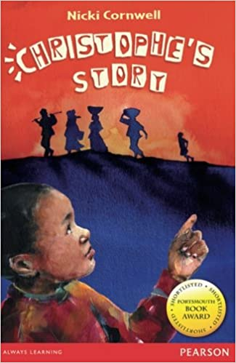 | Year 5  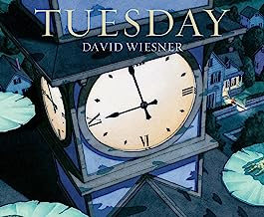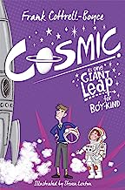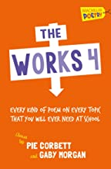
Year 6  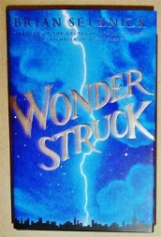  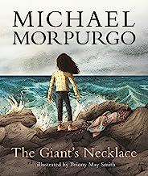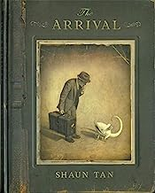 | 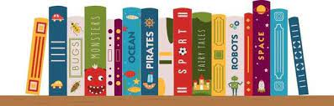
What’s Been This Happening This Term at St Julie’s?
World Book Day  On Thursday 2nd March, World Book Day, the children thought about their own favourite authors and came to school dressed as a book character or they came with their favourite bedtime book dressed in pyjamas or a onesie.  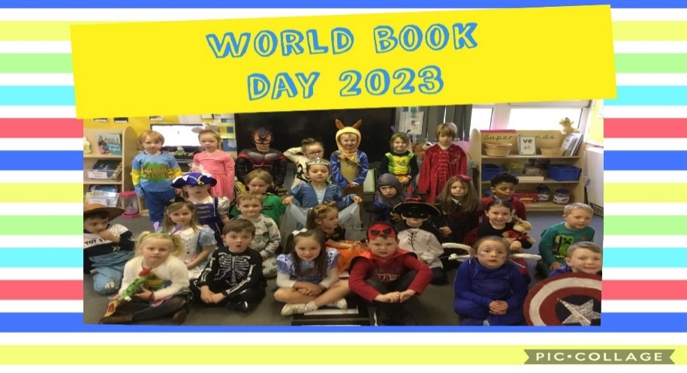 | Children’s Mental Health Day Reading  Children’s Mental Health Day was from 6th – 12th February 2023. We have a range of books in our school that explore our feelings and individuality. These are just some of our recommendations:
 | EYFS/KS1  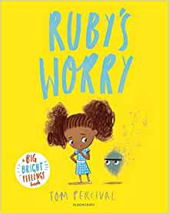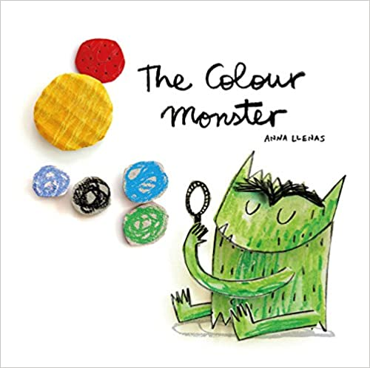 |  | KS2  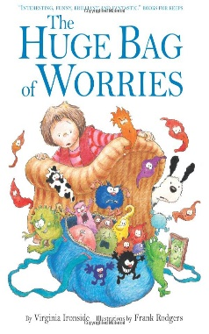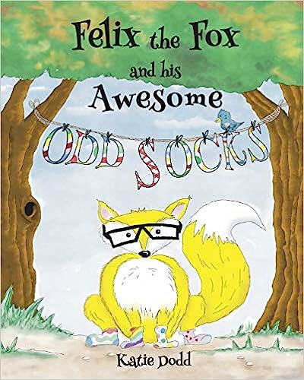
Share a story Sessions  Grown-ups and children enjoyed a relaxing time in the hall, snuggling up on the bean bags to share a cosy reading session  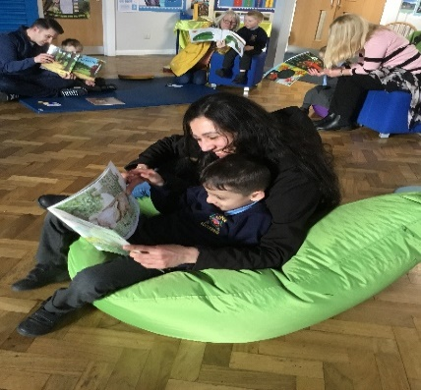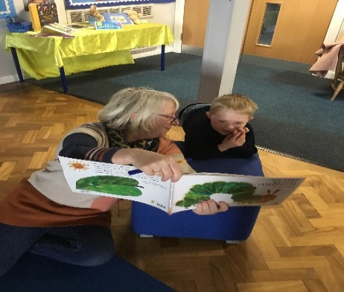 | Book Swap  The Reading Ambassadors enjoyed organising a book swap on World Book Day. Children brought in one book in good condition to swap (forever!) for another book. | World Poetry Day  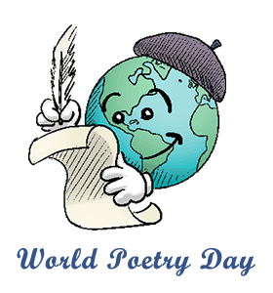  The theme for World Poetry Day was "Always a Poet, Even in Prose." On Tuesday 21st March all classes enjoyed listening to and writing a variety of different poems
Visits to Eccleston Library  All year groups have enjoyed walking along to Eccleston Library and looking at the selection of books. Our Y1 and Y5 children have been introduced to new books written by a wide range of authors as part of BASH (Book Awards St Helens) at Eccleston Library. They had the chance to read them all and then voted for their favourite.  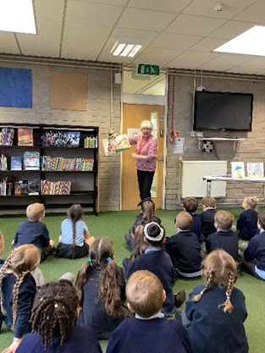 | 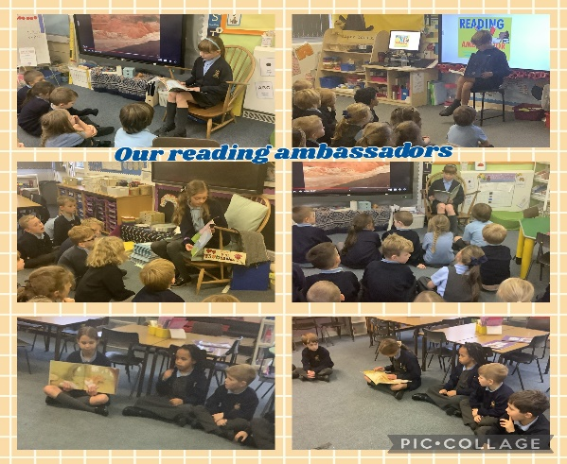  Reading Ambassadors  Our Year 5 and Year 6 Reading Ambassadors visited the infants in their classrooms to share a story with the children. They enjoyed reading aloud to the infants and asking them questions about the story
Staff Reading Interviews
Our Reading Ambassadors spoke with Mrs Mannion:  What is your favourite book for KS1?  The Owl Who Was Afraid of The Dark  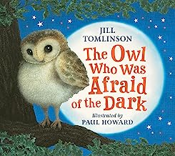  What genre is this book?  Fiction Book  Why do you recommend this book?  This book is filled with gentle humour and has fabulous illustrations. Plop the barn owl is my favourite character and during the book he makes many surprising discoveries. The message of resilience is also so important. | Our Reading Ambassadors spoke with Mr Royle:  What is your favourite KS2 book?  The Boy Who Grew Dragons  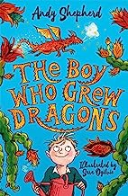  Do you prefer fiction or non-fiction books?  I prefer reading non – fiction books as they share facts or real-life events. They are also great tools for making real-world connections to build on your knowledge and personal experiences.  Where is your favourite place to read and why?  On a sun lounger as it helps me relax and get lost in the book
Coming up in the Summer Term
Reading Boat  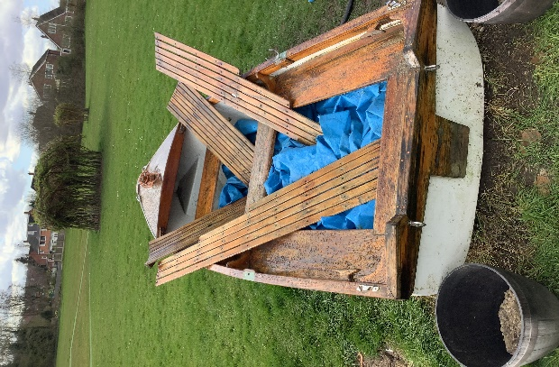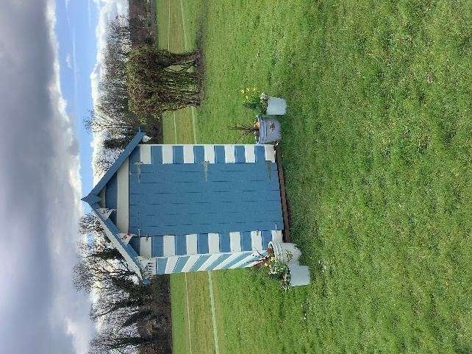  During the Summer term the Reading Ambassadors will be inviting classes to enjoy reading in our reading boat | Our brand-new reading recommendation bookmarks for all classes!  