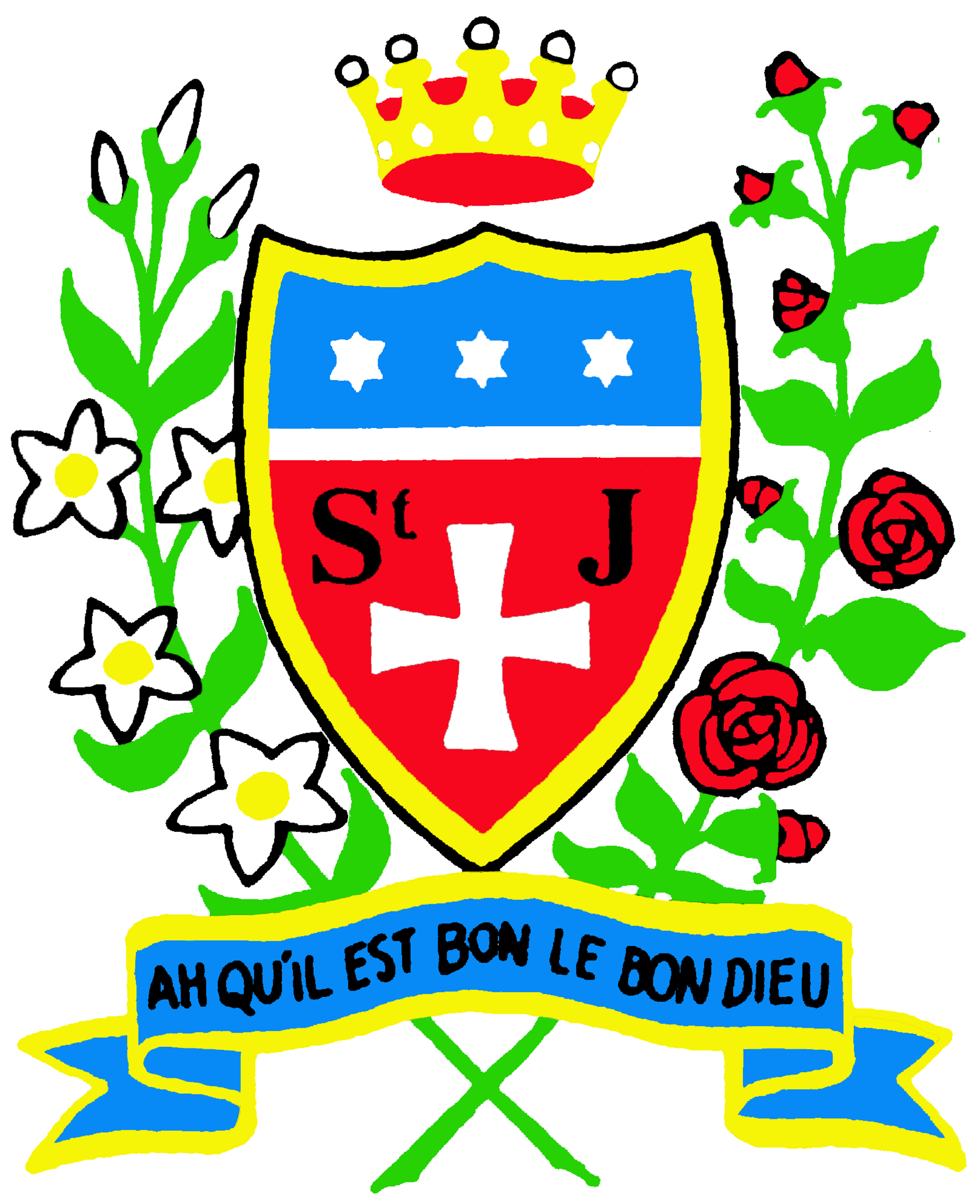

ST. JULIE CATHOLIC PRIMARY SCHOOL - ECCLESTON

CURRICULUM POLICY STATEMENT

MISSION STATEMENT

St Julie Catholic Primary School.
A caring, family school where we learn, grow
and walk in the footsteps of Jesus.

In consequence of our school mission it is a fundamental aim of St. Julie’s to be an inclusive school. To be a school which:-
- Has a sense of community
- Provides equal opportunities
- Offers partnership between school parents and parish
- Reflects upon the teachings of Christ and puts them into practice
- Values all members of the school community
- Its members show respect for themselves and each other
- Is a caring community.

We define an inclusive school as one where…

- Everyone, irrespective of age, gender, ability or disability, race or religion is encouraged and given equal opportunity to participate in the full life of the school,
- All members of the school community are given the opportunity and support to achieve their true potential,
- All members of the school community, and the contributions they make to the life of the school, are valued and where everyone is treated with mutual respect, care and consideration, and
- Everyone feels empowered to play a full an effective role in the school.

1. Summary
The Curriculum is the total of all learning experiences that St Julie’s School provides for the children in its care. We aim to provide a broad, balanced curriculum for all pupils, at all stages of their development. Through the curriculum we aim to enable children to reach their full potential and develop their talents, interests and skills. We do this by teaching the full range of subject areas through the six areas of learning, and choosing the appropriate teaching methods to take account of the wide variety of learning styles of children. We seek to provide opportunities for development, not only through academic subjects, but through all aspects of the school day, including break and lunch times, assemblies and extra- curricular activities.

2. Aims of the Curriculum
The curriculum comprises all activities planned within school and extended through homework. In delivering the curriculum at St Julies, it is our aim that all children:
- Access a curriculum that provides opportunities for them to learn and achieve
- Have opportunities to build upon their strengths, interests and experiences and develop their confidence in their ability to learn independently and work collaboratively
- Discover an enjoyment of, and commitment to, a lifetime of learning
- Engage in fun as well as serious study because enjoyment leads to enhanced learning
- Are equipped with the essential skills of literacy, numeracy and computing
- Are encouraged to develop an enquiring mind and rational thought, and to be broad and balanced in their views
- Have the opportunity to be creative, innovative and enterprising
- View themselves with positive self-esteem and emotional well-being to help them to form worthwhile relationships
- Develop the capacity for leadership and teamwork and to equip them for life as healthy, active, responsible, Global Citizens

3. Curriculum Delivery
The curriculum is based on the September 2014 National Curriculum for Key Stages 1 & 2 and the Early Years 2014 framework in Reception.

Reading and Phonics in Key Stage 1
At Key Stage 1 the Oxford Reading Tree, Rising Stars and Project X reading schemes are used to develop the acquisition of reading skills and foster a love of books. All children in EYFS and Key Stage 1 follow the “Letters and Sounds” teaching programme, participating in daily phonics sessions.

Early Years
In the Reception we use Development Matters, non-statutory guidance to implement statutory requirements. At this stage, children will be learning skills, acquiring new knowledge and demonstrating their understanding through 7 areas of learning and development.

Children should mostly develop the 3 prime areas first. These are:
- Communication and language
- Physical development
- Personal, social and emotional development

These prime areas are those most essential for healthy development and future learning. As children grow, the prime areas will help them to develop skills in 4 specific areas. These are:
- Literacy
- Mathematics
- Understanding the world
- Expressive arts and design

These 7 areas are used to plan learning and activities. We ensure that the activities are suited to the unique needs of each child.

Key Stage 1 and 2
In planning for the new National Curriculum, introduced to St Julie’s in 2014, with the whole school community, we took the best of the ‘old’, plus thinking from the ‘new’ to create dynamic and memorable learning for our children.

Some subjects may be taught individually. However, where appropriate, we promote a topic based curriculum, where subject matter is more relevant when linked together. In such instances, we have adopted a ‘Challenge Curriculum’ which promotes a cross-curricular enquiry based approach to learning.

The following subjects are taught at St Julie’s:
- English
- Mathematics
- Religious Education
- Science
- Design and Technology
- History
- Geography
- Computing
- Music
- Art and Design
- Personal, Social, Health and Citizenship Education
- Physical Education
- Spanish
- French

The National Curriculum statutory guidance provides the structure for our planning. We follow the Liverpool Archdiocesan guidance for the teaching of Religious Education.

As well as the core and foundation subjects listed above, we also aim to equip children with a good understanding of the outside world and the ability to make informed and sensible choices. To support this, and within the context of a caring, Catholic community, we teach Sex and Relationship Education and Drugs Education.

How we teach: Learning styles
In planning our curriculum teachers at St Julie’s Primary School understand that children learn in a variety of ways. Teachers take into account the following learning styles:
- Visual: Visual learners benefit from being visually presented with information such as graphs, charts, posters, concept mapping etc.
- Auditory: Auditory learners benefit from discussion activities, lecture-style lessons, interviewing, reading, hearing stories, language games etc.
- Kinaesthetic: Kinaesthetic learners benefit from physical activity, modelling, field trips, visits, learning by ‘doing’.

4. Key Skills
At St Julie’s Primary School we know that key skills are those that help learners to improve their learning and performance in education, work and life. These are embedded in the National Curriculum and we aim to equip children with each:
- Communication
- Application of number
- Information Technology
- Working with others
- Improving own learning and performance
- Problem Solving

5. Thinking Skills
These help children to focus on ‘knowing how’ as well as ‘knowing what’ to learn and are also embedded in the National Curriculum, complementing the key skills:
- Information processing skills
- Reasoning skills
- Enquiry skills
- Creative thinking skills
- Evaluation skills
- Discussing/debating skills

6. Inclusion
At St Julie’s Primary School we believe that Inclusion means that:
- Every child matters
- Every child should be helped to feel that they belong
- We seek to ensure that all pupils achieve to the best of their ability
- We recognise that we have children from differing backgrounds and we give every child the opportunity to experience success
- We set high expectations and provide opportunities for all children to achieve
- Some children may have particular learning and assessment requirements, either through having Special Educational Needs, learning differences, or may be linked to pupil’s progress in learning English as an additional language
- We recognise particular needs of gifted and talented children, providing strategies which challenge their thinking, understanding, knowledge and skills

We take account of these requirements and make provision through differentiation and other methods, as far as is possible, to support individuals or groups of pupils to participate in curriculum and assessment activities.
7. Assessment, Reporting and Recording
At St Julie’s Primary School we understand that assessment is at the heart of the teaching and learning process. It is our aim that assessment:
- Enables us to identify children’s strengths and weaknesses
- Informs future planning
- The assessment procedure is a positive one for children, which celebrates their current achievements
- The sharing of assessment information develops the partnership between pupils, teachers and parents

How We Assess
Reception pupils are assessed using the Foundation Stage Profile. Pupil profiles are established for each child in Reception and assessments are made against the Foundation Stage Profile Statements.

Short and medium term assessment is the responsibility of the class teacher
and is in line with the assessment policy. However, teachers will use informal assessment and observation on a daily basis to determine what children can do independently and therefore plan next steps for learning. Children’s progress and attainment in each subject will be assessed by their teacher against the learning outcomes and end of year expectations.

Formative assessments take many different forms and are reflected in detailed marking and the provision of constructive feedback. Feedback identifies areas for children to improve, giving focused challenges. Children are given the opportunity to respond and reflect on their work in order to improve.

Summative assessments support teacher assessments in the core subjects and children are presented with these in a relaxed format so as to cause minimal anxiety for pupils. These are used to help prepare children though the
year groups for the end of key stage testing as required by law.

Assessment for learning (AFL) is a major factor in raising children’s standards of achievement. Methods may include:
- Classroom talk
- Questioning
- Giving appropriate feedback
- Sharing criteria with learners
- Peer and self-assessment
- Shared target setting etc.

Reporting
Pupil progress will be reported to parents at three points in the year either in writing or at an appointment where parents are invited to discuss their child’s progress.

Autumn 2016

