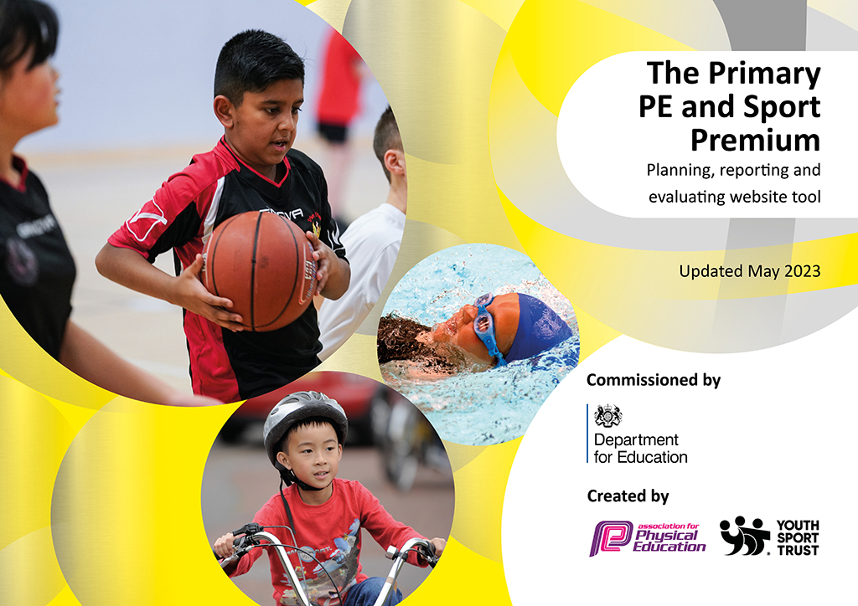
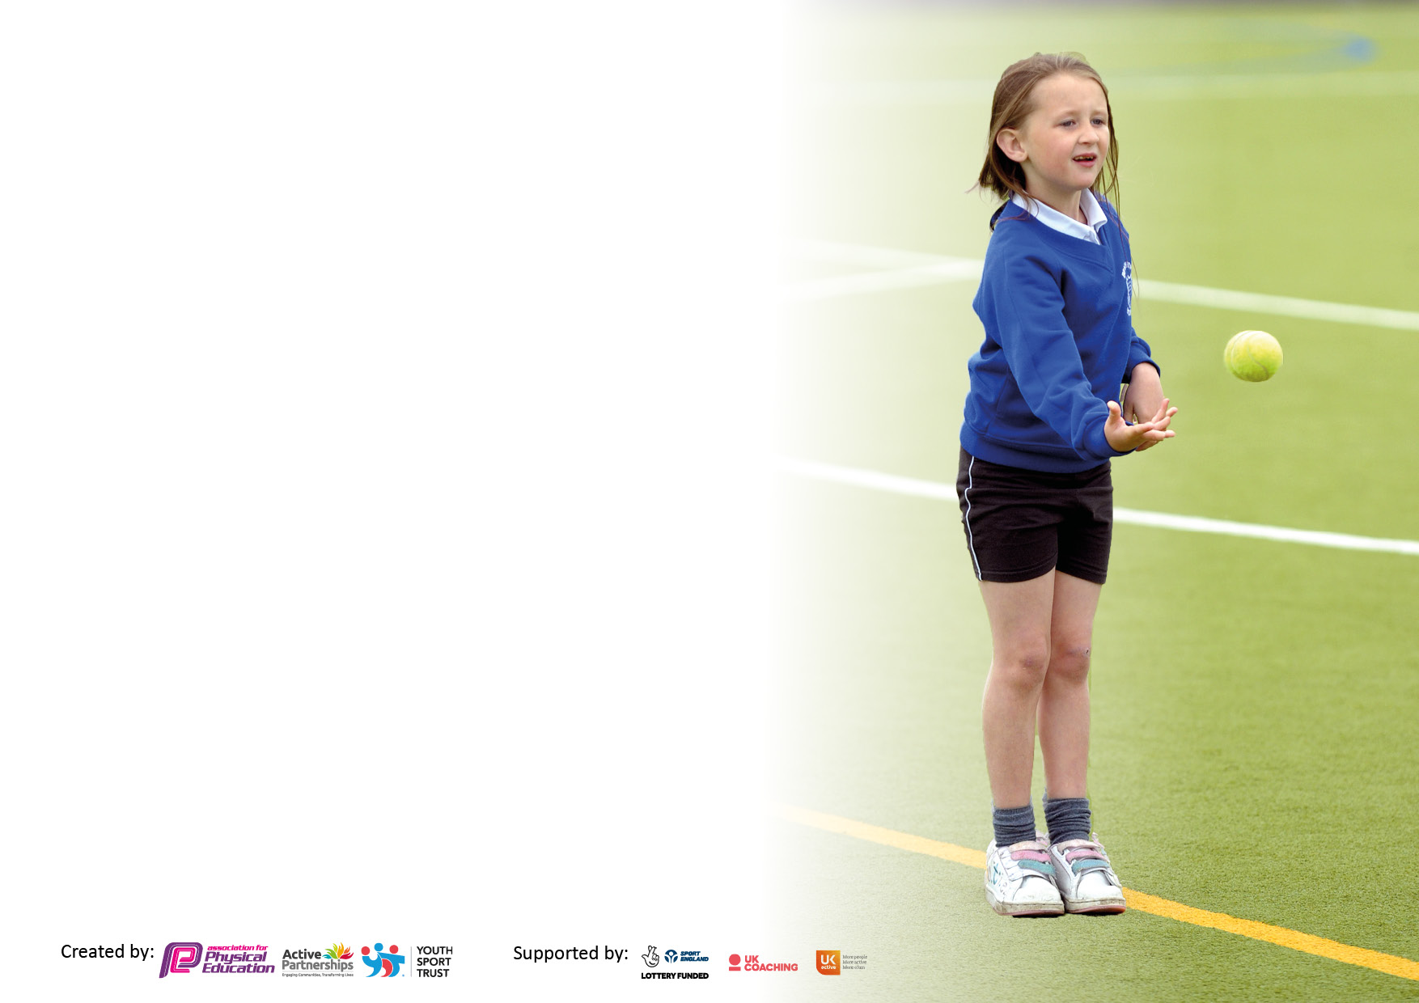

It is important that your grant is used effectively and based on school need. The Education Inspection Framework makes clear there will be a focus on ‘whether leaders and those responsible for governors all understand their respective roles and perform these in a way that enhances the effectiveness of the school’.

Under the Quality of Education Ofsted inspectors consider:
Intent - Curriculum design, coverage and appropriateness
Implementation - Curriculum delivery, Teaching (pedagogy) and Assessment
Impact - Attainment and progress

To assist schools with common transferable language this template has been developed to utilise the same three headings which should make your plans easily transferable between working documents.

Schools must use the funding to make additional and sustainable improvements to the quality of Physical Education, School Sport and Physical Activity (PESSPA) they offer. This means that you should use the Primary PE and sport premium to:

- Develop or add to the PESSPA activities that your school already offer
- Build capacity and capability within the school to ensure that improvements made now will benefit pupils joining the school in future years
- The Primary PE and sport premium should not be used to fund capital spend projects; the school’s budget should fund these.

Pleasevisitgov.ukfortherevisedDfEguidanceincludingthe5keyindicatorsacrosswhichschoolsshoulddemonstrate animprovement.Thisdocumentwillhelpyoutoreviewyourprovisionandtoreportyourspend.DfEencouragesschools to use this template as an effective way of meeting the reporting requirements of the Primary PE and Sport Premium.

We recommend you start by reflecting on the impact of current provision and reviewing the previous spend.

Schools are required to publish details of how they spend this funding, including any under-spend from 2021/2022, as well as on the impact it has on pupils’ PE and sport participation and attainment. All funding must be spent by 31st July 2023.

We recommend regularly updating the table and publishing it on your website throughout the year. This evidences your ongoing self-evaluation of how you are using the funding to secure maximum, sustainable impact. Final copy must be posted on your website by the end of the academic year and no later than the 31st July 2023. To see an example of how to complete the table please click HERE.

Details with regard to funding
Please complete the table below.

Total amount carried over from 2021/22 | £1,013.75
Total amount allocated for 2021/22 | £18,090
How much (if any) do you intend to carry over from this total fund into 2022/23? | £1,013.75
Total amount allocated for 2022/23 | £18,084
Total amount of funding for 2022/23. To be spent and reported on by 31st July 2023. | £19,097.75
Swimming Data
Please report on your Swimming Data below.

Meeting national curriculum requirements for swimming and water safety.

N.B. Complete this section to your best ability. For example you might have practised safe self-rescue techniques on dry land which you can then transfer to the pool when school swimming restarts.
Due to exceptional circumstances priority should be given to ensuring that pupils can perform safe self rescue even if they do not fully meet the first two requirements of the NC programme of study
What percentage of your current Year 6 cohort swim competently, confidently and proficiently over a distance of at least 25 metres?  N.B. Even though your pupils may swim in another year please report on their attainment on leaving primary school at the end of the summer term 2022.  Please see note above | 83%
What percentage of your current Year 6 cohort use a range of strokes effectively [for example, front crawl, backstroke and breaststroke]?  Please see note above | 83%
What percentage of your current Year 6 cohort perform safe self-rescue in different water-based situations? | 83%
Schools can choose to use the Primary PE and sport premium to provide additional provision for swimming but this must be for activity over and above the national curriculum requirements. Have you used it in this way? | No

Action Plan and Budget Tracking
Capture your intended annual spend against the 5 key indicators. Clarify the success criteria and evidence of impact that you intend to measure to evaluate for pupils today and for the future.

Academic Year: 2022/23 | Total fund allocated: £19,097.75 | Date Updated: July 2023
Key indicator 1: The engagement of all pupils in regular physical activity – Chief Medical Officers guidelines recommend that primary school pupils undertake at least 30 minutes of physical activity a day in school |  |  |  | Percentage of total allocation:
 |  |  |  | 24%
Intent | Implementation |  | Impact
Your school focus should be clear what you want the pupils to know and be able to do and about  what they need to learn and to  consolidate through practice: | Make sure your actions to achieve are linked to your intentions: | Funding allocated:  £4,689 | Evidence of impact: what do pupils now know and what can they now do? What has changed? | Sustainability and suggested next steps:
- 2 hours quality PE lessons  - Monthly Mile Competition/Trophies  - Promotion of the 60 Active Minutes throughout school  - Enhanced membership of SHAPES  - Swimming lessons for Years 4, 5 and 6 during curriculum time  - Improving active playtimes  - Children’s University | Ensure 2 hours of allocated PE each week on the school timetable (KS1 and KS2)  Children are encouraged to use the running track on a regular basis – in and outside of PE lessons. Trophies awarded for the fastest and most improved runners each month  Physical Activity Trackers throughout school to monitor activity levels  We have maintained the participation in Level 2 (inter-school) sports competitions – offered by the St Helens School Games Team. Ensuring that we have entered all types of competitions – e.g. those for the gifted and the least active  Play Leaders/ Y6 Buddies  In order to graduate, KS2 children participated in a range of extra- curricular sports clubs | £749  £1,440.00  £2,500.00 | Children are improving their “personal bests” in the monthly mile  Staff and children are aware of the Government guidelines on physical activity – trackers were used to provide evidence for the School Games Platinum Award  Membership leads to improvements of all indicators – e.g. CPD, sports festivals and competitions etc.  23 inter-school events participated in this academic year – encompassing all types of competitions – aspire, inspire and celebrate.  100% of children in Years 5 and 6 participated in an inter-school event this year.  3 members of staff are trained as swimming coaches  KS1 staff have praised the Year 6 children for helping to create and implement playground games.  100% of the current KS2 cohort were awarded a Children’s University certificate this academic year. | Lesson observations and review long term plans regularly.  Continue to promote throughout the school year – via assemblies, school bulletin.  Deliver CPD.  Swimming sessions are booked for the next academic year.  Ensure that the current Year 5 children are trained as playground buddies in Year 6.  Encourage all children to participate in the C.U. Scheme.
Key indicator 2: The profile of PESSPA being raised across the school as a tool for whole school improvement |  |  |  | Percentage of total allocation:
 |  |  |  | 2.6%
Intent | Implementation |  | Impact
Your school focus should be clear what you want the pupils to know and be able to do and about  what they need to learn and to  consolidate through practice: | Make sure your actions to achieve are linked to your intentions: | Funding allocated:  £500 | Evidence of impact: what do pupils now know and what can they now do? What has changed?: | Sustainability and suggested next steps:
- To continue to maintain the current levels of intra and inter school competitions. To ensure that a range of competition types are entered via the St Helens School Games Programme.  - 60 Active Minutes.  - Regular celebration of sports participation and achievement – both in and outside of the school day.  - To ensure that all children are aware of the importance of a healthy lifestyle – including diet, mental health and wellbeing, as well as regular exercise. | Enter all classes into both intra and inter school events during the next academic year.  Remind staff to encourage 30 active minutes daily in school.  Share achievements with pupils in Celebration Assemblies, the school bulletin, website and photographs to be displayed on the PE/Sports display boards.  Promote healthy eating, mental health and wellbeing throughout the school. This is not only taught in PE, but also DT, Science and PSHE. | £500 | Keep the Platinum Award.  Children and staff are more active  Evidenced through trackers and Sports Participation Grids in Teacher Share Drive.  Children are more aware of the links between their physical and mental health. St Julie’s also received a Wellbeing Award for their efforts and achievements throughout recent years. | Remind children regularly – e.g. assemblies and curriculum time – about the importance of sport and its accessibility to ALL.  We would like to continue to promote the importance of our physical and mental health – not only through our rich curriculum, but also through the Wellbeing Ambassadors and the Change Team.

Key indicator 3: Increased confidence, knowledge and skills of all staff in teaching PE and sport |  |  |  | Percentage of total allocation:
 |  |  |  | 60%
Intent | Implementation |  | Impact
Your school focus should be clear | Make sure your actions to | Funding | Evidence of impact: what do | Sustainability and suggested
what you want the pupils to know | achieve are linked to your | allocated:  £11,500 | pupils now know and what | next steps:
and be able to do and about | intentions: |  | can they now do? What has
what they need to learn and to |  |  | changed?:
consolidate through practice:
- PE Specialists to deliver PE alongside St Julie staff.  - PE specialist to deliver PE CPD to St Julie staff.  - Borough wide CPD opportunities offered to all staff.  - Improve quality of PE lessons. | Subject specialist employed to teach PE (with relevant staff member) across key stages – to ensure a consistent approach throughout the school.  All staff to take advantage of CPD opportunities throughout the borough. | £11,000  £500 | Expertise passed on to staff and an increased confidence when teaching PE.  Our Year 4 teacher feels much more confident now, when teaching tennis and gymnastics – due to CPD.  We also have three TAs who have an accredited certificate in teaching swimming. They now teach a group during swimming sessions. | We plan to continue our SHAPES membership each year to ensure access to network meetings, CPD and resources. This will enable us to offer a high-quality PE curriculum.
Key indicator 4: Broader experience of a range of sports and activities offered to all pupils |  |  |  | Percentage of total allocation:
 |  |  |  | 4.7%
Intent | Implementation |  | Impact
Your school focus should be clear | Make sure your actions to | Funding | Evidence of impact: what do | Sustainability and suggested
what you want the pupils to know | achieve are linked to your | allocated:  £900 | pupils now know and what | next steps:
and be able to do and about | intentions: |  | can they now do? What has
what they need to learn and to |  |  | changed?
consolidate through practice:  At St Julie’s we offer a wide range of extra-curricular clubs to all children. Including: football, rugby, multi skills, gymnastics, table-tennis, judo, cheerleading and athletics.  Through the St Helens School Games we enter a wide range of sports competitions – to ensure that ALL abilities have a chance to represent the school at an inter-school event. | Ensure that a range of clubs are offered to children, tying in with both the curriculum and Level 2 competition. |  | The extra-curricular club registers illustrate that an increased percentage of children are taking part in after school sports clubs. (Saved in Teacher Shared Drive.)  The Sports Participation Grids (Teacher Share Drive) illustrate that ALL children have the opportunity to represent St Julie’s in an inter-school competition – regardless of ability. | Pupil Voice – get the opinions of children via the School Sports Ambassadors.  Continue to monitor the range of competitions entered and the number of children who have taken part.

Key indicator 5: Increased participation in competitive sport |  |  |  | Percentage of total allocation:
 |  |  |  | 10%
Intent | Implementation |  | Impact
Your school focus should be clear | Make sure your actions to | Funding | Evidence of impact: what do | Sustainability and suggested
what you want the pupils to know | achieve are linked to your | allocated:  £2000 | pupils now know and what | next steps:
and be able to do and about | intentions: |  | can they now do? What has
what they need to learn and to |  |  | changed?
consolidate through practice:
- Half-termly intra/inter-school sports competitions.  - Engagement in St Helens – enhanced provision offer.  - Maintain existing links (create new ones) with other local schools.  - Sports Day/Charity events to further promote sports, fun and fundraising.  - Encourage children to always strive to achieve their “Personal Best.” | Enter competitions and ensure that all staff are involved in which events we enter and that we offer a range for ALL abilities. Throughout each term and across both key stages.  Arrange friendly football matches.  Arrange transport for events.  Organise our next Sports Day in line with our new format. E.g. House Teams (mixed ages) – were the focus was fun, “personal bests” and teamwork, as well as achievement. | £2000 | St Julie’s have been successful in School Games competitions this year. We won the KS2 Gymnastics St Helens Final and represented St Helens in the Merseyside School Games Final. In addition, the Year 3 and 4 children came first in the St Helens Quadkids Athletics competition. In the Year 6 Rugby World Cup Competition, we got to the final of the St Helens School Games Event. This year we have continued to encourage our girls to enter the Girls Football events and the Year 3 team reached the semi-finals and one of our players received the Star Player Award. | Continue to enter a range of inter-school sports events and to create more links with local schools.

Signed off by
Head Teacher: | A Hodgson
Date: | 12/07/2023
Subject Leader: | L Clayton
Date: | 27/06/23
Governor: | T Sims
Date: | 12/07/2023

