 **Summer Term Newsletter**

As you know, at the beginning of the year St Julie’s took up the challenge to, 'Live Simply' working towards gaining the CAFOD Live Simply Award for our school.

The award is all about protecting our planet and the people on it. It is given to communities who can show how they:

* live simply
* live sustainably with creation.
* live in solidarity with people in poverty.

I am delighted to say that on Monday of this week Mrs McCahey, myself and a group of our St Julie’s children met with the Cafod assessor to talk about our Live Simply journey this year and to discuss all the evidence that had been submitted. As always our children spoke confidently about the many ways they have lived simply, sustainably and in solidarity with people in poverty. Following our discussion we were told that we had achieved the Live Simply Award for St Julie’s in recognition of all we do for our school, the local community and the global community.

**Live Simply**

We have continued to celebrate our year of living simply:

**Our Arts Week** this year was led by our Live Simply theme. Staff and children were asked to consider how we could celebrate the themes of:

Live Simply, Live in Solidarity and Live Sustainably

Year 5 took the theme of ‘Live Simply’ and focussed on a mindfulness project. They used harmonious colours to create a relaxing colourwash for each square and then developed a ‘Zentangle’ pattern. The children said they found this artwork really enjoyable and relaxing.

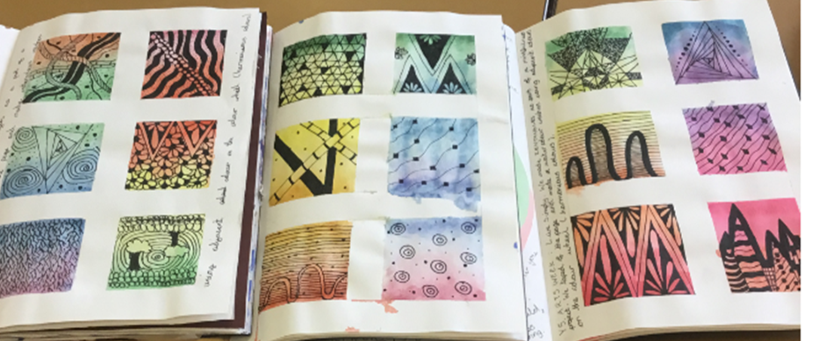

An art competition continued to celebrate our theme. We were presented with many lovely pieces of art celebrating the beauty of God’s creation.

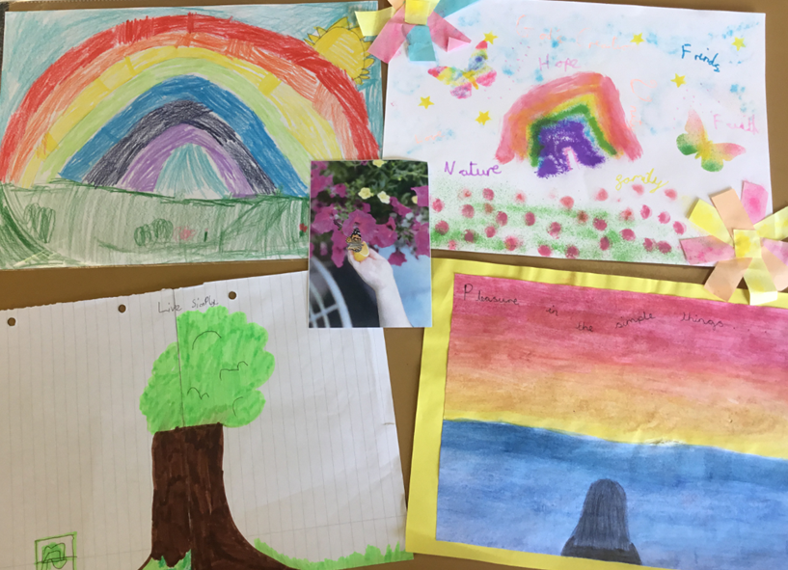

We have taken time in our busy lives to ‘Live Simply’.

* Forest School remains an important part of our curriculum and a time that all our children thoroughly enjoy; pupils and staff can take time to appreciate the awe and wonder of creation.

Year 3 worked with the artist Claire Weetman on a project called “Wishes on the wind.” This was an observational drawing session where the children looked at seasonal natural forms collected from the school grounds. Their drawings were transformed into rubber stamps, which they used to create individual prints, and an animated artwork. The activity focused on how seeds are symbols of hope, that can be planted and grown, a mirror to the learning journey that happens within a school. Scan the QR code to see our group pieces of art and hear our poems.

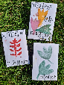

* Each class had a Capoeira session during Arts week. Capoeira is an Afro-Brazilian martial art that combines elements of dance, acrobatics, music and spirituality.
* Year 3 took part in Story Walk using our environment to stimulate creativity.
* Reception enjoyed feeding the lambs on their trip to Greenacres farm.
* **Wellbeing Award for Schools** was achieved in June recognisingall we do at St Julie’s to promote the emotional wellbeing and mental health of pupils, staff and parents. The award which recognises the range of support we have on offer throughout school, the focus on wellbeing that weaves throughout our curriculum and is at the heart of our school ethos.
* St Julie Catholic Primary School achieved the **School Games Platinum Mark Award** for the 2022/23 academic year recognising how we keep all our children physically active.

**Live sustainably**

Care for our environment has a high profile as we try to live the Pope’s message of Laudato Si’- care for our common home, the Earth.

* Year 2 went to Norton Priory and explored the grounds as they looked for insects, charmed worms and went pond dipping.
* On the Year 5 trip to the Blue Planet Aquarium the children considered the dangers of pollution and plastics in our rivers, seas and oceans.
* Year 2 Southport Eco Centre – the children enjoyed an immersive environmental experience and also walked through the town looking at the Victorian buildings of a seaside resort.

We continue to promote a range of recycling initiatives these have included:

* Pre-loved uniform exchange
* Parent book swap (in foyer)

Sports ambassadors continue to help log our journeys to school encouraging everyone to make an extra effort to find alternative means of getting to school without using fossil fuels through our ‘Living Streets’ project **“Walk Once a Week.”**

**Live in solidarity**

We have continued to show how we live in solidarity with others near and far by our actions:

* During Refugee week Year 5 took part in a workshop to consider the experiences of refugees. Year 3 and Year 4 visited Eccleston Library during Empathy and Refugee week and participated in activities based on the book “The boy at the back of the class,” by Onjali Rauf.
* During our Faith Encounters day we celebrated the diversity of World faiths. Across school pupils studied the beliefs and culture of Islam, Hinduism and Sikhism. Supporting our understanding of different beliefs, we had visitors form the Jewish, Hindu and Ethiopian Christianity communities. We were fortunate to share with our visitors their traditions and aspects of their faith. Staff and visitors were overwhelmed by the response from the children, who worked with incredible respect and consideration.
* Merseyside Police delivered their Black and Proud assembly to the whole school looking at role models throughout history up to modern day.
* Year 5 learned about human rights through the Rights Here Rights Now programme delivered by Sam, the chaplain, from De La Salle.
* Year 3 engaged with the local community through placing bookmarks in books in the library and writing letters to neighbours. They even received a letter back saying, “Thank you for your lovely card…It is really good that you are thinking of your school neighbours.”
* 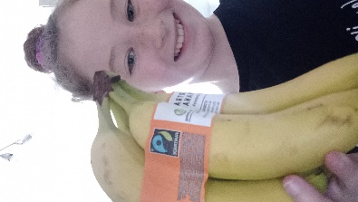**Fair Trade**. We have encouraged our staff and families to live in solidarity with workers. In assemblies, Worship Welcomers have helped to spread the message of a fair wage. In class, some of the children have looked at the economics of trade and some of the injustice of pay. They played the CAFOD ‘Banana Game’. Pupils were shocked to discover how little the farmers earned!
* Many of our families took up the challenge to add at least one Fair Trade item to their shopping, supporting out aim to Live in Solidarity.

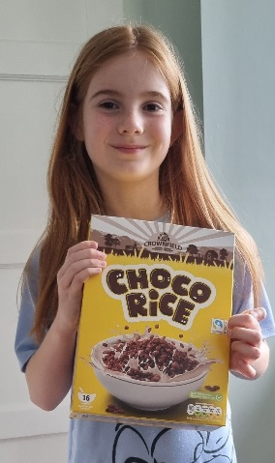 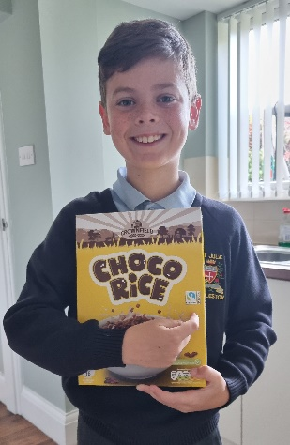 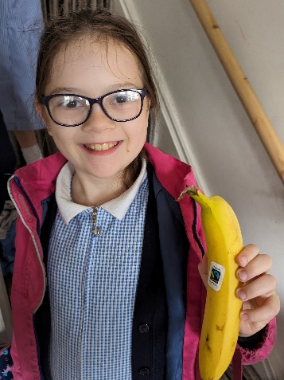 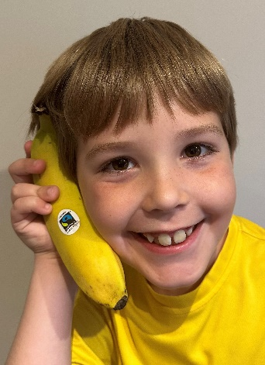

*We are so pleased to have achieved our aim to Live Simply but there is still much more that we plan to do in the next academic year as we continue to follow in the footsteps of Jesus.*

*Our school website has more information about the award on the RE tab under the heading “Living our faith.”*

**Thank you for your support,**

**Mrs Hodgson.**