St Julie Catholic Primary School - Science
Topic: Plants | Year: 1 | Strand: Biology
What should I already know?
I know the names of some plants, trees and flowers.
Make simple observations about plants.
I know we have to care for the world around us

Sticky Knowledge
Seeds grow into plants.
There are different parts of a plant.
Plants need light and water to grow and survive.
We can eat some plants.

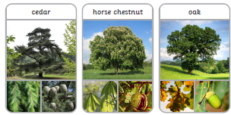

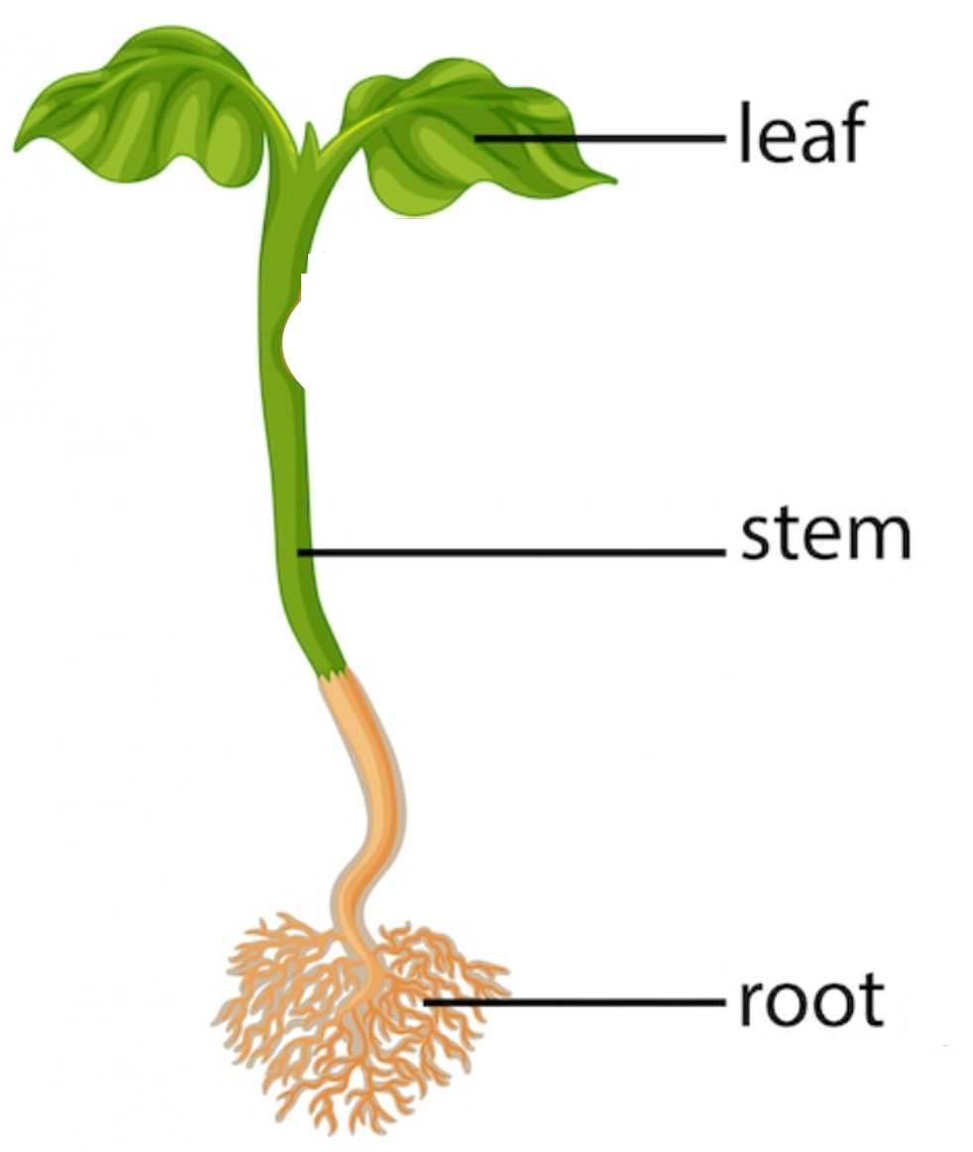
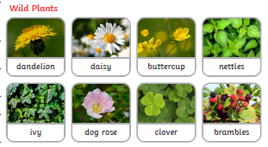
Parts of a plant
Vocabulary
deciduous | Trees that lose their leaves each year
evergreen | Trees that keep their leaves or needles all year round, even in winter.
seed | Seeds grow into new plants.
roots | Take in nutrients and water from the soil.
stem | Holds the plant up and takes nutrients sand water to the leaves and flower.
leaves | Catch sunlight to make energy.

A wild plant seed grows where it falls. It doesn’t need to be planted or cared for as it grows.

