|  |  |  |
| --- | --- | --- |
| St Julie Catholic Primary School - History | | |
|  | Year: 1 | Changes Within Living Memory |

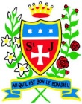

|  |  |
| --- | --- |
| Vocabulary | |
| Past /  Then | Something that happened before |
| Present /  Now | Something that is happening now |
| Chronology | Putting events in order of when they happened |
| Change | Someone or something becomes different. |
| Compare | Look for what is the same and what is different. |
| Local | Close to where you are. |

What should I already know?

* The names of some toys I play with now and in the past.
* Children play with different toys as they get older.
* Something that has already happened is in the past.

**How have Children’s lives Changed Within Living Memory?**

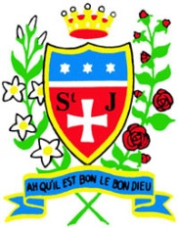





**Sticky Knowledge**

* Older toys are made from wood, metal and cloth.
* New toys can be made from plastic.
* Homes in the 1920’s had plain colours and wooden floors.
* Homes in the 1970’s were colourful.
* Washdays used to be on Monday.
* The first automatic washing machines were very expensive.
* Schools have always had rules.
* Schools didn’t always have computers.
* St Julie school was built in 1966.
* In the past children have listened to music using in different ways.

2023

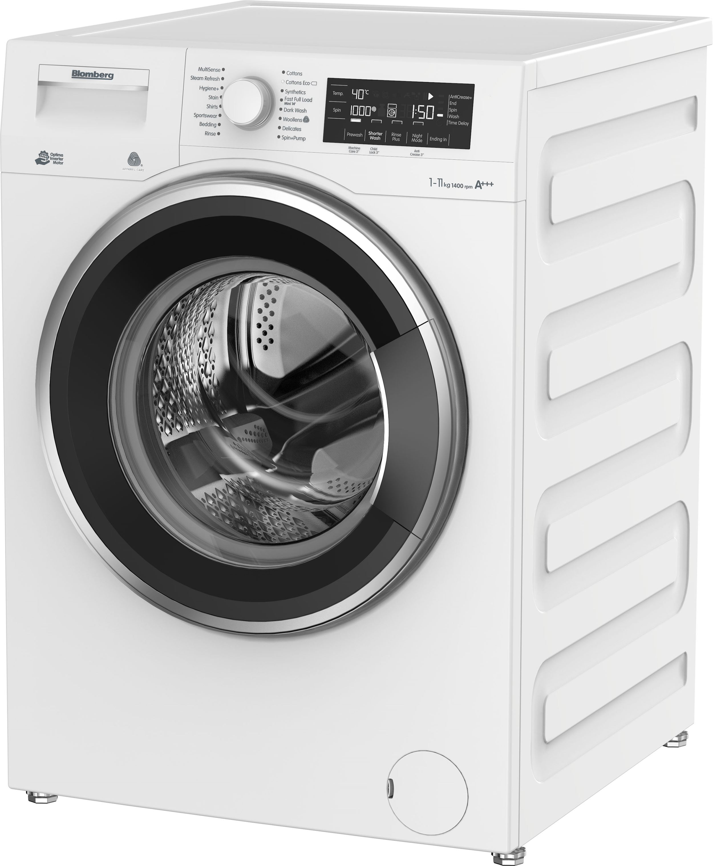

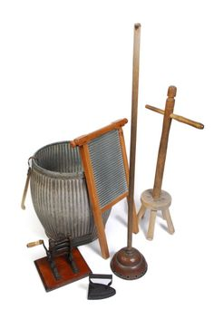

1930’s

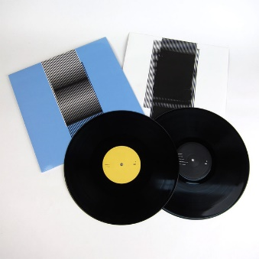

MP3 player

CD

Tape cassette

Vinyl record

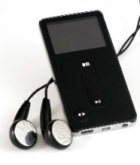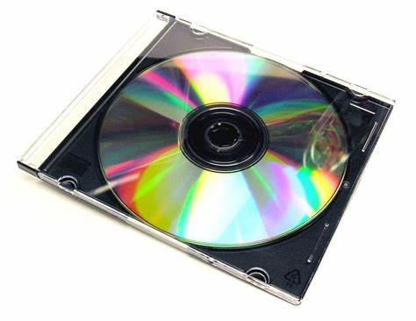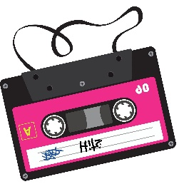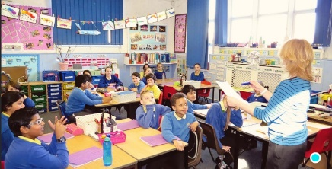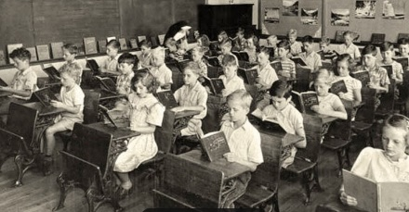

past

present

**History Skills**

* I can identify the main differences between past and present?
* I can compare different elements of life from the past and present.