|  |  |
| --- | --- |
| St Julie Catholic Primary School - History | |
| Year: 1 | Topic: Lives of Significant Individuals in the Past |

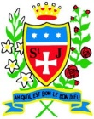

**Why are Queen Victoria and Queen Elizabeth II significant?**

**What should I already know?**

* That kings and queens have ruled our country
* The Monarch now is King Charles III

|  |  |
| --- | --- |
| **Key Vocabulary** | |
| Monarch | A king or queen |
| Royal Family | Members of a royal family |
| Reign | The time that one monarch is king or queen. |
| Coronation | The ceremony of crowning a king or queen. |
| Significant | Something or someone that is important |
| Compare | Finding what is the same or different about something or someone. |

**Sticky Knowledge**

|  |  |  |  |
| --- | --- | --- | --- |
|  |  |  |  |
| **Queen Victoria** | | **Queen Elizabeth II** | |
| She became Queen at 18 years old. | | She became Queen at 25 years old. | |
| She had 9 children. | | She had 4 children. | |
| There are only paintings of her coronation. | | People could watch her coronation on TV. | |
| She lived in Buckingham Palace | | She lived in Buckingham Palace. | |
| Made a law that children had to go to school. | | Longest reigning Monarch – Queen for 70 years | |
| Trains became popular. | | People walked on the moon. | |

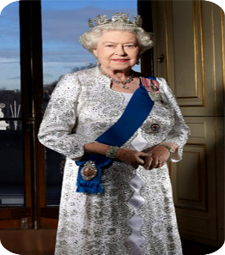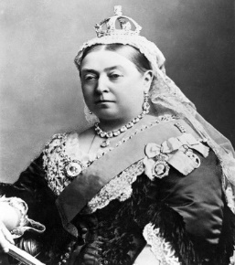

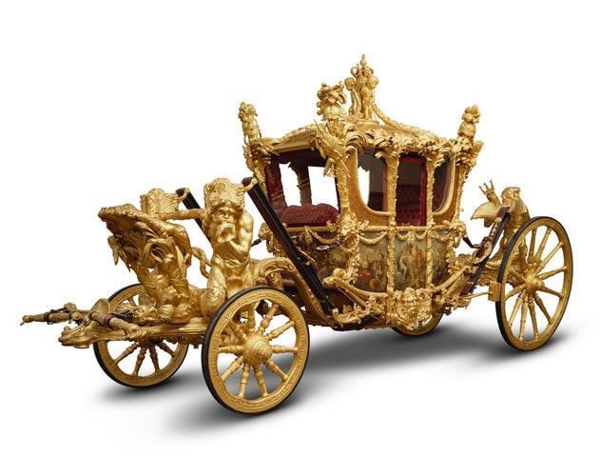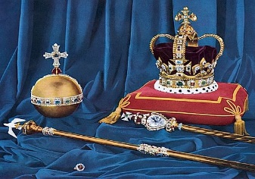

**History Skills** I can identify similarities and differences between the life, coronation and reign of Elizabeth II and Queen Victoria.