|  |  |  |
| --- | --- | --- |
| St Julie Catholic Primary School - DT | | |
| DT – Autumn Term | Year: 2 | **Unit Title: Mechanisms – Wheels and axles** |



|  |  |
| --- | --- |
| Vocabulary | |
| **design** | A plan for the construction of an object |
| **vehicle** | a thing used for transporting people or goods, especially on land, such as a car, lorry, or cart. |
| **Axle** | a rod on which one or more wheels can rotate, either freely or be fixed to and turn with the axle. |
| **Axle holder** | the component through which an axle fits and rotates. |
| **Chassis** | the frame or base on which a vehicle is built. |
| **Dowel** | wooden rods used for making axles to hold wheels |
| **evaluate** | To say what is good or needs improving with your design |

**What should I already know?**

• Assembled vehicles with moving wheels using construction kits.

• Explored moving vehicles through play.

• Gained some experience of designing, making and evaluating products for a specified user and purpose.

• Developed some cutting, joining and finishing skills with card.

**Can I design, make and evaluate a vehicle to get teddy across the classroom?**



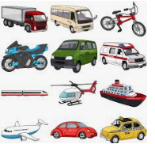

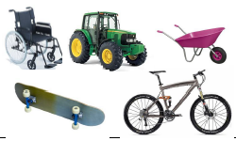

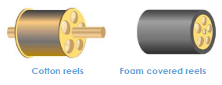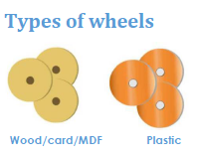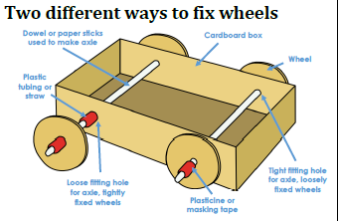

**Skills recap**:

-Using construction kits to make wheeled products

-Use of scissors and hole punches

-Joining card using different methods

**DT Skills:**

-Generate ideas based on simple design criteria and their own experiences, explaining what they could make.

-Develop, model and communicate their ideas through talking, mock-ups and drawings.

**Henry Ford**

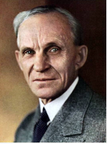 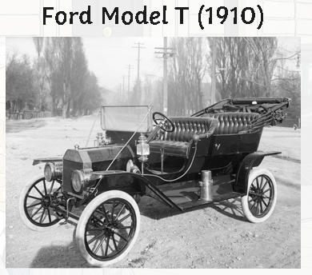

Henry Ford was American. He founded the Ford Motor Company on 16th June 1903.

As a young boy, people used to bring their broken watches to Henry for him to fix.

Ford is currently the leader in UK car sales

**How do I create a wheeled product?**

1, Can I explore different wheeled products, directly observing the number, size, position and methods of fixing wheels and axles?

2. Can I draw an example of a wheeled product, labelling the main parts?

3. Can I use construction kits with wheels and axles to make a product that moves?

4. Can I use samples of materials and components to assemble some examples of wheel, axle, axle holder combinations.

5. Can I draw and label my own designed wheeled product?

6. Can I make my wheel and axle product using their design ideas and criteria as an ongoing guide?

7. Can I evaluate my finished product, communicating how it works and how it matches my design criteria, including any changes I made.



