|  |  |  |
| --- | --- | --- |
| St Julie Catholic Primary School - DT | | |
| DT – Spring Term | Year: 2 | **Unit Title: Food: Potato Salad and Rainbow Coleslaw** |



**Can I design, make and evaluate a Potato Salad and Rainbow Coleslaw for a family picnic?**

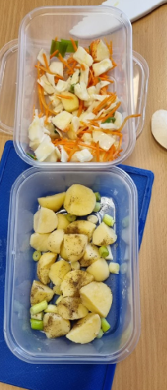

|  |  |
| --- | --- |
| Vocabulary | |
| **slice** | A thin piece of food cut from a larger portion. |
| **grate** | Cut food into tiny pieces by rubbing on a grater |
| **peel** | Remove the skin from fruit and vegetables. |
| **healthy** | Being fit and well |
| **ingredients** | Parts of a recipe or mixture |
| **salad** | a cold dish of fresh and/or cooked vegetables or  fruit. |
| **claw grip** | A common method used when cutting to protect fingers. |
| **bridge hold** | A common method especially used when cutting rounded foods. |

**What should I already know?**

Making fruit salads in EYFS.

Making healthy garden salad in Year 1.

They will be familiar with the names of fruit and vegetables.

**Prior Vocab:**

design, make, evaluate.



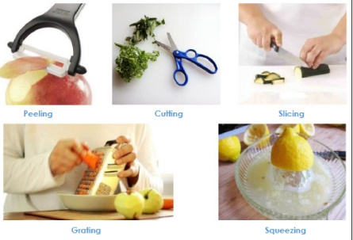

**Skills recap:**

-Designing for a purpose (Who is the product for?)

-Importance of personal hygiene and food handling

**DT Skills:**

- Design purposeful, functional, appealing products for themselves and other users based on design criteria.

- Select from and use a wide range of materials and components, including construction materials, textiles and ingredients, according to their characteristics.

- Explore and evaluate a range of existing products

- Evaluate their ideas and products against design criteria.

**How do I create a potato salad and Rainbow coleslaw?**

1 -Can I say what a root vegetable is? Can I sort vegetables that grow above and below ground?

2 -Can I explore, taste and describe a variety of root vegetables?

3 -Can I plan my potato salad and Rainbow coleslaw salad?

4 -Can I make a potato salad and rainbow coleslaw?

5 -Can I evaluate the salad making process?

**Nadiya Hussein**

Nadiya won the Great

British Bake Off 2015.

She is about to have

her 6th cook book

published called ‘Fast Flavours.’

She has had 3 cookbooks story books for children called Bake Me A Story.

**Common methods when cutting foods**

Claw grip Bridge hold



