|  |  |  |
| --- | --- | --- |
| St Julie Catholic Primary School - DT | | |
| DT – Summer Term | Year: 2 | **Unit Title: Textiles – Templates and Joining** |



**Can I design, make and evaluate a puppet to be used in Reception?**

|  |  |
| --- | --- |
| Vocabulary | |
| **design** | A plan with ideas for a product. |
| **glove puppet** | A glove puppet fits over the hand, and the fingers operate its head and arms. |
| **template** | A shape drawn to assist in cutting out shapes. |
| **Sew** | To join pieces of fabric with stitches. |
| **Seam** | A row of stitches joining two pieces of fabric. |
| **Appliqué** | To attach a decorative fabric item onto another piece of fabric by gluing and/or sewing. |
| **evaluate** | To say what is good or needs improving with your design |

**What should I already know?**

Explored and used different fabrics.

• Cut and joined fabrics with simple techniques.

• Thought about the user and purpose of products.



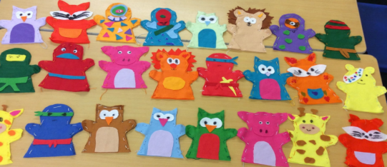

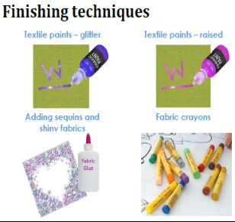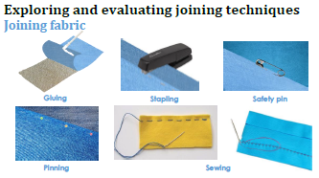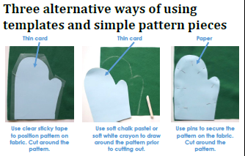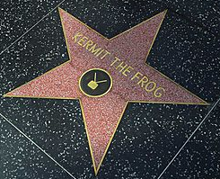

**How do I create a puppet?**

1, Can I investigate existing puppets, looking at fabrics, joining techniques, finishing techniques?

2. Can I make drawings of existing puppets and identify and label the fabrics, fastenings and techniques used?

3. Can I demonstrate use of a template, correct use of tools and some joining techniques finishing techniques?

4. Can I generate a range of ideas? Can I draw and label my own puppet design?

5. Can I make my puppet following the stages of assembly and applying the knowledge, understanding and skills I have learnt.

6. Can I evaluate my puppet against my design criteria?

**Skills recap**:

-Use of scissors and glue

**DT Skills:**

Understand how simple 3-D textile products are made, using a template to create two identical shapes.

• Understand how to join fabrics using different techniques e.g. running stitch, glue, over stitch, stapling.

• Explore different finishing techniques e.g. using painting, fabric crayons, stitching, sequins, buttons and ribbons.

**Jim Henson**

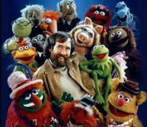

* He is [American](https://kids.kiddle.co/Americans) [artist](https://kids.kiddle.co/Artist), [animator](https://kids.kiddle.co/Animator), [puppeteer](https://kids.kiddle.co/Puppet), and [moviemaker](https://kids.kiddle.co/Movie).
* Best known for his work with [the Muppets](https://kids.kiddle.co/The_Muppets), which he helped to create.
* His best-known puppet is [Kermit the Frog](https://kids.kiddle.co/Kermit_the_Frog).



