School Games

Year 5/ 6 Sportshall Athletics
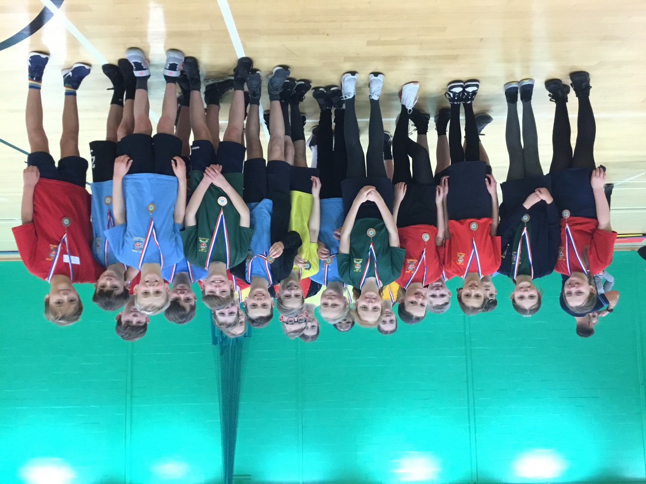

Congratulations to our amazing athletes from Year 5 and 6, who obtained bronze medals in the recent St Helens athletics competition.

What a TEAM – Together Everyone Achieves More!
Thank you to Daryl for his support.

