

Eco Code

*The children, staff and governors of St Julie will do their best to care for our common home, the Earth. We will:*

**Expect to reduce our carbon footprint**

**Care for our common home**

**Open our eyes to the beauty of creation**

**Care for the wildlife in our school grounds**

**Organise recycling events**

**Decide to make eco-friendly choices**

**Encourage our families to share our eco hopes**

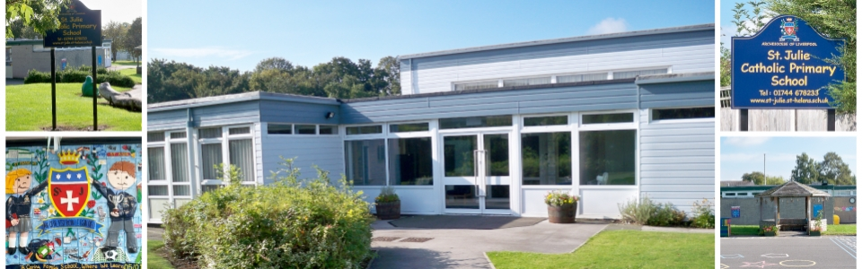

**Caring for our common home**