Dear Parents/Carers, 

**Learning to read: supporting your child at home**

Reading is one of life’s most essential skills. At St Julie Catholic Primary School, we hope that all children will develop a love of books, enthusiasm for promoting their reading skills and grow to be confident, competent readers. As a parent or carer, you play a vital role in supporting your child’s reading development, our partnership between home and school is essential for success with this life skill.

**

At school we are using the *Oxford Reading Tree* series to take your child through the early stages of learning to read. We are using the *Floppy’s Phonics* teaching programme, which is a step-by-step phonics reading scheme. It introduces the children to the letters and sounds (the alphabetic code) that are at the foundation of all reading and writing.

To reinforce the teaching in school, your child may bring home some books to share with you. These may be:

● *Floppy’s Phonics Sounds Books*, to practise the sounds and letters taught at school

● *Floppy’s Phonics* decodable readers to practise reading stories and different text types.

All the books have notes on the inside cover to guide you on how to share them with your child.

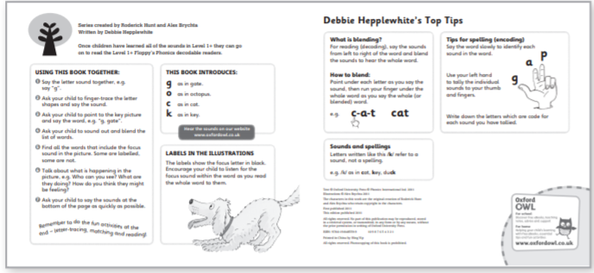

Each child will also have a phonics folder which may contain Grapheme and Picture Tiles, Activity Sheets, Cumulative Texts, *Activity Books* and Say the Sounds Posters for your child to practise phonics at home.

You may like to visit [www.oxfordowl.co.uk](www.oxfordowl.co.uk%20) for further information about phonics, helping your child to read and for free resources and eBooks.

Children will also still be assigned books from Bug Club to support with their phonic knowledge and they will also bring home a library book of their choice.

This Reading Record is for you to record the title of the school book, how many times it has been read and any comments you wish to make. You may want to include other texts that your child has read at home, but this is not a requirement.

**How can parents and carers support children**

Parents can support this 'reading journey' through regular reading at home. Reading to and with your child every evening for at least ten minutes can make a dramatic difference to a child's achievement within school.

Here are some tips for reading with your child at home, including:

1. Make time to read- even ten minutes a day.
2. Choose different types of books.
3. Take turns to read.
4. Talk about the book- asking your child questions. Please note, at the back of your child’s book are a set of questions and activities you can do together to support the comprehension aspect of reading.
5. Visit the local library together and enjoy book-talk about your favourite texts.
6. Read comics, web site, environmental signs, instructions in fact anything at all.

Thank you for your continued support

EYFS and KS1 Team