School Games

Year 3/4 Sportshall Athletics
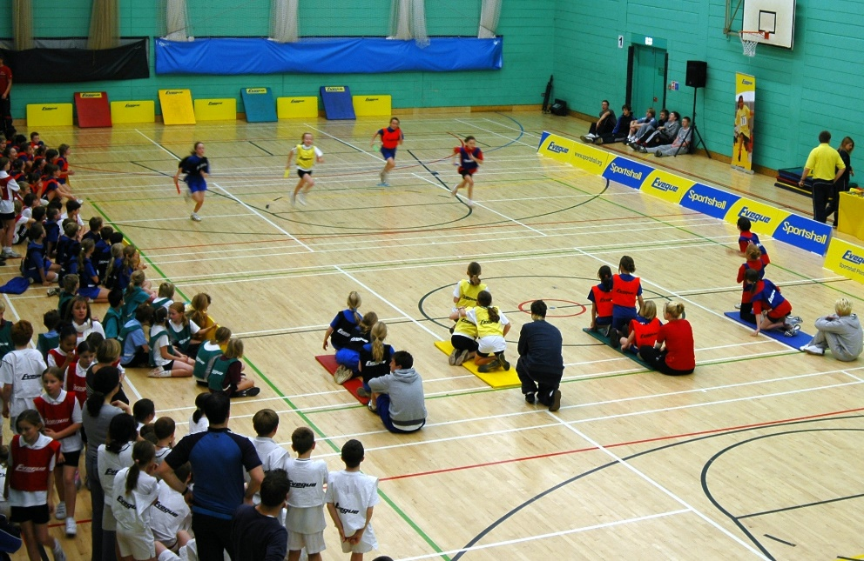

Congratulations to our amazing athletes from Year 3 and 4, who obtained bronze medals in the recent St Helens athletics competition.

What a TEAM – Together Everyone Achieves More!

