The Wall
L.O. I can start sentences in different ways
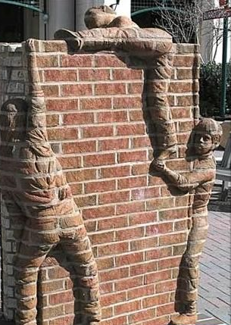

They had always wondered what lay beyond the wall. Now they knew. Who could they tell? How could they tell?
The day had started just like any other: the sun rose; the birds sang; clouds of the purest white drifted across the deep blue sky.

