St Julie’s Monthly Mile Challenge

The current record stands at 7.41 minutes!
Can you beat this???

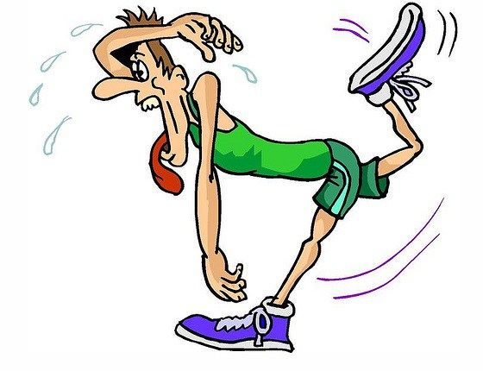
Don’t worry if you can’t – just compete against yourself! Try to get a Personal Best.

Awards for the Most Improved Runner and the Fastest Runner!

(9 laps of the circular track on the field or 9 laps of both playgrounds.)

