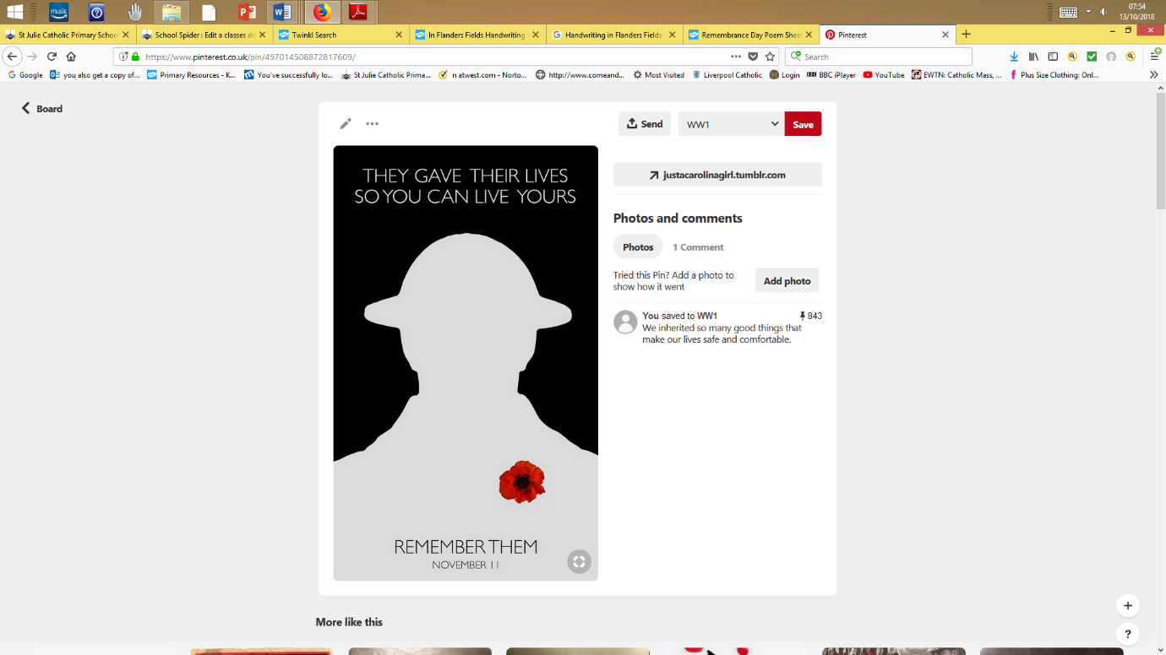

1914-1918

St Julie Remembers