Year 6 School Games

Football Festivals
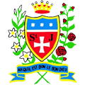

Congratulations to the Year 6 girls and boys who represented St Julie’s in the recent football festivals at Ruskin Drive. A tremendous performance from both of our teams – well done!
We are very proud of you all!
Remember our motto: TEAM – Together Everyone Achieves More.

