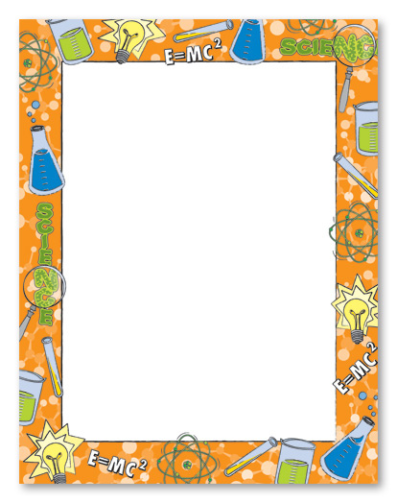

Science at St Julie is:
- Wonderful and interesting
- We plan our own investigations
- We use interesting resources
- We learn through having fun
- We always learn something new
- We do lots of experiments to answer questions
- Science helps to understand the world
