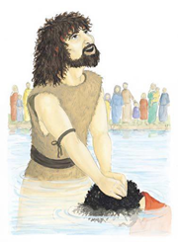
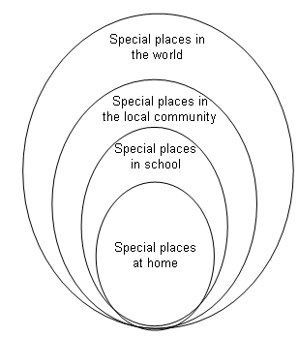
Special Places
Universal Church- World

BIG question
What makes a place special?
Write your ideas on our class blog.

Think about special places for Jesus. It is possible today to visit many of the places associated with the life of Jesus in what Christians call the Holy Land.
Look at some of the scripture…
Luke 2: 11 Bethlehem Matthew 2: 23 Nazareth
Luke 2: 41, 46 Jerusalem Mark 1: 9 Baptism in the Jordan
Matthew 5: 1−2 Sermon on the mount

Some key questions
Q Where were the special places for Jesus?
Q Why were they special?
Q Why do you think some of these places are still special and holy today?
Q Why are these places so special for Christians today?

Activities
- Collect photographs of the places that may be special to the children and ask them to name the equivalent special place for Jesus (e.g. local maternity hospital – stable at Bethlehem; their local church – Temple). Ask the children to say what happened at each special place.
- Invite the children to choose and retell their favourite story about Jesus, stating where it happened, why it was special and explaining why it is a special place for people today.

