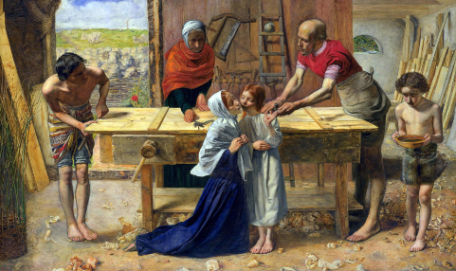
Homes
Domestic Church - Family
BIG question
What makes a house a home?
Write your ideas on our class blog.
KEY WORDS
home, family, love, difference, respect, joys, sorrows

Recall the story of Mary, Joseph and Jesus, having to escape to Egypt, because Herod wanted to harm Jesus and how the family eventually returned to Nazareth. Jesus grew up there and learnt the trade of a carpenter. Jesus was brought up in the Jewish faith to love and know God. Read Luke 2: 39-40.

SOME KEY QUESTIONS
Look at the picture; what do you notice about how the family are showing love and care?
What do you think was important in their home?
How do you think Mary helped Jesus grow up?
How do you think Joseph helped Jesus?
What do you think Jesus’ day was like?
What do you think they are saying to one another?

ACTIVITIES
Imagine you are the curator of an art gallery, write a description of the Millais’ Carpenter’s Shop for visitors to the gallery, showing how the Holy Family are loving and caring towards each other.
Freeze frame the Millais’ Carpenter’s Shop picture, and each character in turn say how they are living as a happy family.

