|  |  |  |
| --- | --- | --- |
| History | | |
| Topic: What changes happened in Britain from the Stone Age to the Iron Age? | Year: 3 | Strand: Stone Age to Iron Age |



What should I already know?

Year 1-Changes across time- Toys since the 1950s.

Year 2- Sequencing events on a time line- Great Fire of London.

|  |  |
| --- | --- |
| **Vocabulary** | |
| Prehistory | The period of time before written/recorded history. |
| Archaeologist | People who work out our history by looking at artefacts that have been found. |
| Palaeolithic | Old Stone Age. |
| Mesolithic | Middle of the Stone Age. |
| Neolithic | Towards the end of the Stone Age. (The ‘new’ Stone Age) |
| Artefact | An object made by human beings, using with historical interest. |
| Civilization | A group that lived during a period of time long ago. |
| Settlement | A place where people establish a community. |

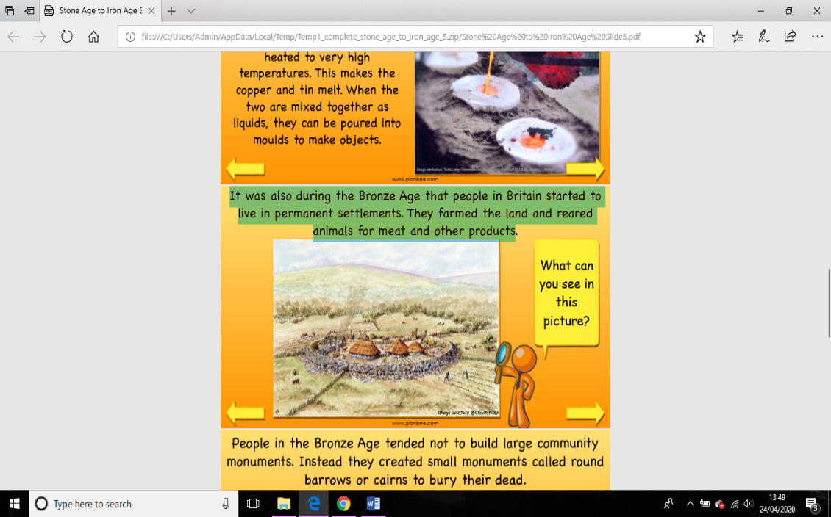

|  |
| --- |
| Early Stone Age people did not have homes but travelled to follow the food. They took shelter in caves or made tents using animal skins. |

|  |
| --- |
| By the Bronze Age, people  were living in small  **settlements** that were made  up of their family members. |

|  |
| --- |
| The Celts lived in much larger  Settlements built on the top of  hills. These were known as **hill**  **forts** and gave the community  protection from other tribes. |

Settlements

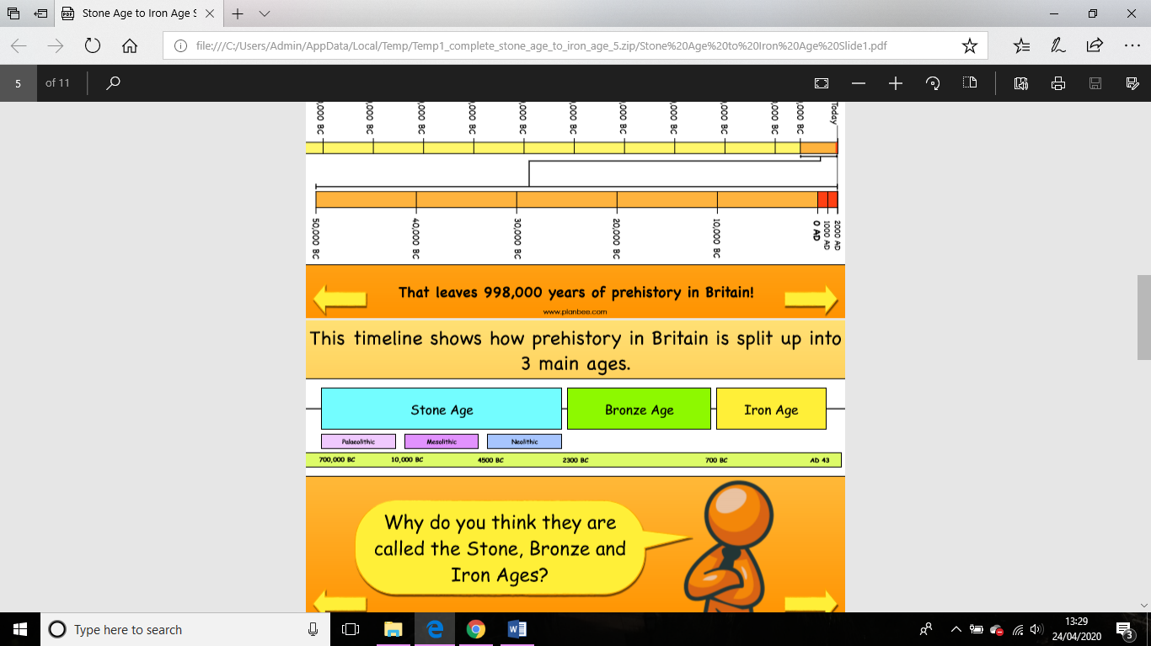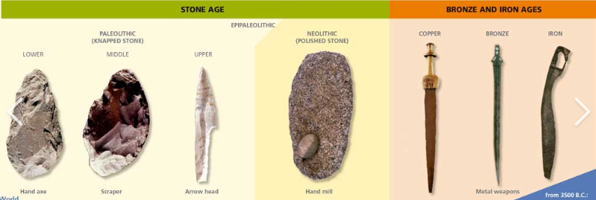

What will I learn during this unit?

1. What does ‘prehistory’ mean? What was it like in the ‘old’ stone age?
2. What was new about the new stone age?
3. How are our ideas about life in the Stone Age changing?
4. Is Bronze better than stone?
5. How is iron made and what was it used for?
6. What was the impact of bronze and iron tools?
7. When do you think it was better to live -Stone Age, Bronze Age or Iron Age?

**History skills**

I can sequence artefacts and events across the 3 eras.

I can (summerise/explain) the key changes from Stone Age to Iron Age.

**Sticky Knowledge**

The Stone age has 3 different periods:

* **Paleolithic**

Humans created basic tools from stone(flint) (axes, spears)

They were hunter gatherers – hunted animals and gathered lands to eat.

* **Mesolithic**

People are still Hunter gatherers.

They used more advanced, smaller, polished tools. (Bow and arrow, canoes)

First huts were built.

* **Neolithic**

Farming first began - Humans still hunted animals but also began to grow food for themselves.

Trees chopped down to create areas where people could settle. First buildings built from enormous rocks (megaliths). (Stone Henge and Skara Brae)

We know a lot about early humans because a lot of material has been preserved in caves.

**Bronze Age**

-Humans farmed the land and reared animals for meat and other products.

|  |  |
| --- | --- |
| -Metals were used to make hunting tools. | |
| **Iron Age**  -Humans now used iron to make tools.  -They farmed land instead of hunting.  -They lived in communities. |

Tools