St Julie Catholic Primary School - Geography
Why do some earthquakes cause more damage than others? | Year: 3 | Strand: Locational & Place Knowledge, Human & Physical geography
What will I learn during this unit?
- Why 22nd February 2011 is important in NZ and world geography.
- How New Zealand has been affected by earthquakes in the past.
- Why New Zealand has so many earthquakes.
- Why the largest earthquakes always cause the most death and destruction.
- Why most volcanoes happen in the same places as earthquakes.
- What the Pacific Ring of fire is.
Sticky Knowledge
- New Zealand is in the Southern Hemisphere.
- New Zealand lies on the edge of the Australian and Pacific Plate.
- On 22 February 2011, at 12:51 pm, Christchurch was struck by a magnitude 6.3 earthquake.
- The Christchurch earthquake caused extensive damage to infrastructure and buildings. Multiple buildings collapsed, and the city was impacted by burst water mains, flooding and power outages.
- Most earthquakes and volcanoes occur because of the movement of tectonic plates.
- The Ring of Fire is a path of active volcanoes and frequent earthquakes around the Pacific Ocean. The majority of Earth's volcanoes and earthquakes take place here.
What should I already know?
- Year 1- Identify four countries (England, Northern Ireland, Scotland and Wales) that make up the United Kingdom.
- Year 2 - There are 7 continents Asia, Africa, North America, South America, Antarctica, Europe and Oceania.
- There are 5 oceans, The Pacific, Atlantic, Indian, Artic and Southern Ocean.
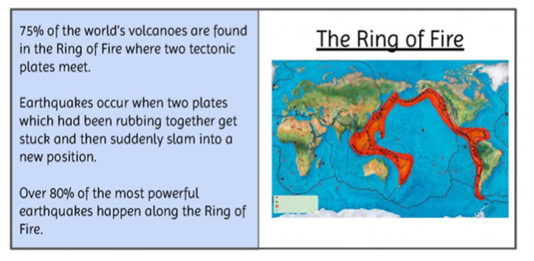
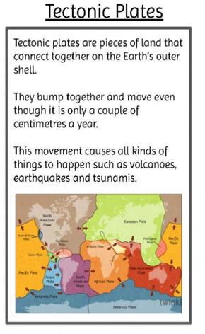
Geography skills
I can locate, describe and explain why so many earthquakes happen around the Pacific Ring of Fire.
I can understand and explain why the most powerful earthquakes do not necessarily cause the most destruction.
How many of the plate names can you remember?
Vocabulary
Earthquake | A shaking or other movement of part of the earth's surface. It is caused by movement deep within the earth. Earthquakes can cause the ground to split.
Epicentre | The point directly above where an earthquake or an underground explosion originates.
Magnitude | A number that shows the size, extent, dimension or power of an earthquake.
Distribution | How something is spread out over an area.
Tectonic plate | Separate sections of the Earth’ crust.
Hemisphere  -Northern  -Southern | The Equator is an imaginary line that circles the middle of the Earth. It divides the Earth into two halves.

