St Julie Catholic Primary School
 | Year: 2 | Significant Local People and events
Why was Samuel Taylor
important to Eccleston?
What should I already know?
- Taylor Park is in Eccleston.
- Features of Taylor Park.
- What a green space is.

Vocabulary
The past | Any time before now.
The present | Something that is happening now
Victorian times | The time when Queen Victoria ruled England from 1837 to 1901.
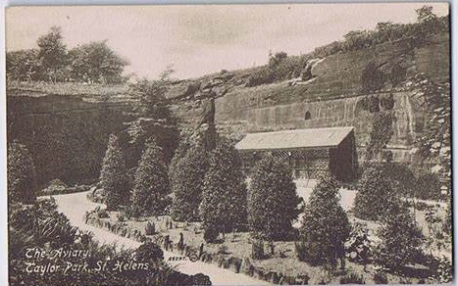  Cotton Trader | A person who buys and sells cotton
Quarry | A large deep pit, from which stone or other materials have been removed
Sandstone | A type of rock made of sand grains that can be red, yellow, or brown in colour.
Community | A group of people living in the same place.
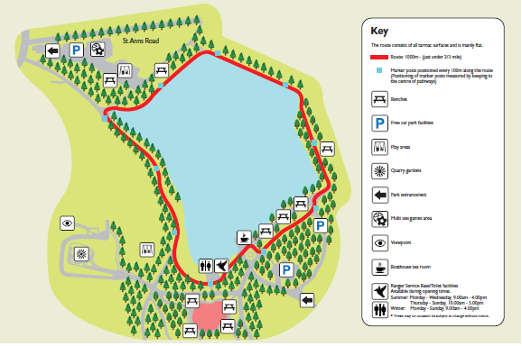
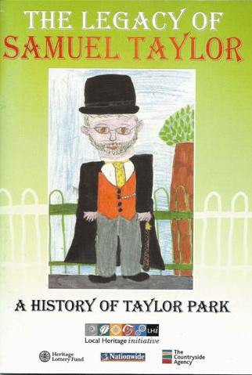
Taylor Park
Taylor Park Quarry
Sticky Knowledge
- Samuel Taylor lived in Victorian times.

- Samuel Taylor lived in Eccleston Hall in Eccleston, St Helens.
- Samuel Taylor was from a rich family who were Cotton Traders.
- Samuel Taylor paid for Christ Church to be built with sandstone from the quarry.
- Samuel Taylor gifted the St Helens community with part of his gardens to create a green space which they named Taylor Park after him.
- The name of ‘The Magpie Inn’ was charged to ‘The Griffin Inn’ to say thank you to Samuel Taylor as there was a griffin on the Taylor Coat of Arms.

History Skills
I can recognise that Samuel Taylor is a significant person to Eccleston.
I can describe why he is important.

