St Julie Catholic Primary School - Geography
Our Local Area | Year: 2 | Strand: Place Knowledge and Fieldwork
What should I already know?
St Julie Primary School is in Eccleston.

Why are green spaces
important to Eccleston?
Vocabulary
Eccleston | A residential area of  St Helens.
residential | A place that people live. A location where there are lots of houses.
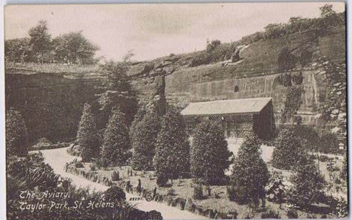  park | A large open area with grass and trees, a place where people can relax and enjoy themselves.
farmland | Land owned by a farmer which is used for growing crops or grazing animals.
green space | An area of grass or trees in an urban area that are used for leisure activities.
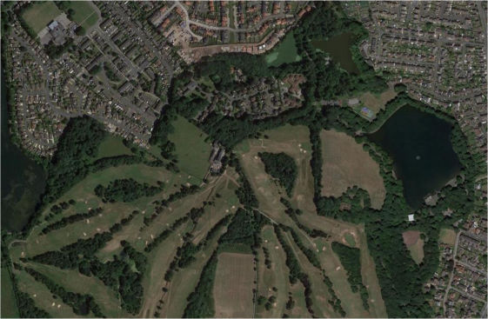
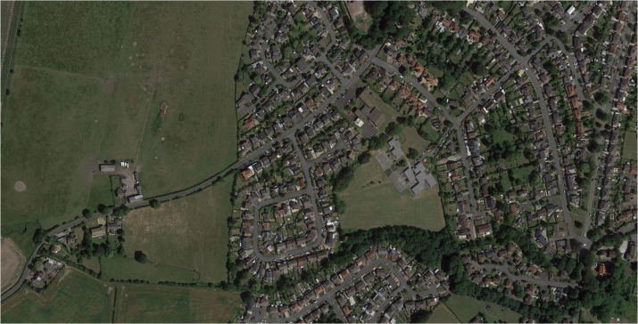
Geography Skills
I can recognise Taylor Park and other green spaces on a map of Eccleston.
I can describe the human and physical features of Eccleston
Sticky Knowledge
- St Helens is in the North West of England.
- The local area of our school is Eccleston, St Helens.
- Eccleston is a residential area.
- There is farmland at the edge of Eccleston.
- A green space is an area of grass or woodland, that is open for people.
- People can go to green spaces to enjoy themselves, exercise or relax.
- It is important to protect our green spaces.

Taylor Park, Eccleston, St Helens.
St Julie’s School, Eccleston St Helens.

