|  |  |  |
| --- | --- | --- |
| St Julie Catholic Primary School - Science | | |
| Topic: Uses of everyday materials | Year: 2 | Strand: Chemistry |

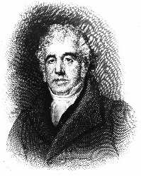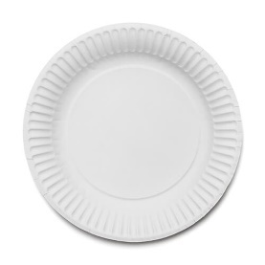 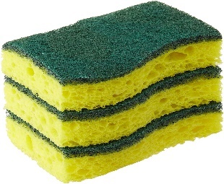

**Charles Macintosh** was a Scottish chemist

and the inventor of waterproof fabric.

The Mackintosh raincoat is

named after him

**This sponge is very absorbent and soaks up the water**

**What should I already know?**

I should know the names of some everyday materials.

I should know some properties of everyday materials.

I should know the difference between an object and the material it is made from.

I can sort objects into different groups to show what they are made from.

**This plate would be best for a party because it is very stiff.**

|  |  |
| --- | --- |
| **Vocabulary** | |
| **Material** | The ‘stuff’ an object is made from |
| **Property** | A way to describe something. |
| **Object** | A thing that can be seen or touched. |

**Sticky Knowledge**

**1.I know** that everyday materials have their own properties- wool insulates (keeps us warm)

**2.I know** why I would choose a material for a particular job- A window is made from glass because I can see through it.

**3**.**I know** that I can change the shape of objects by **squashing, bending,** **stretching** and **twisting.**

**4.I know** that John McAdam invented a new way to make roads.

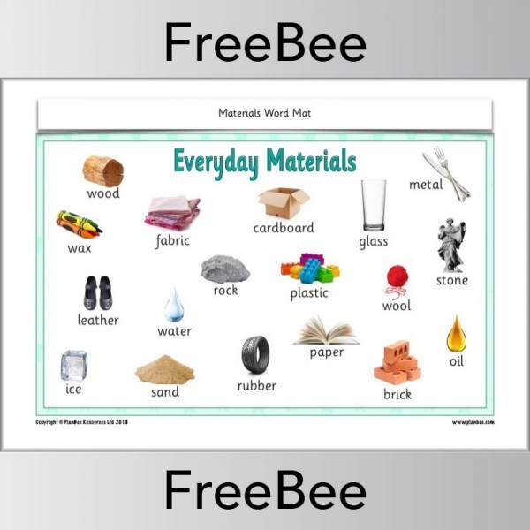

Material properties

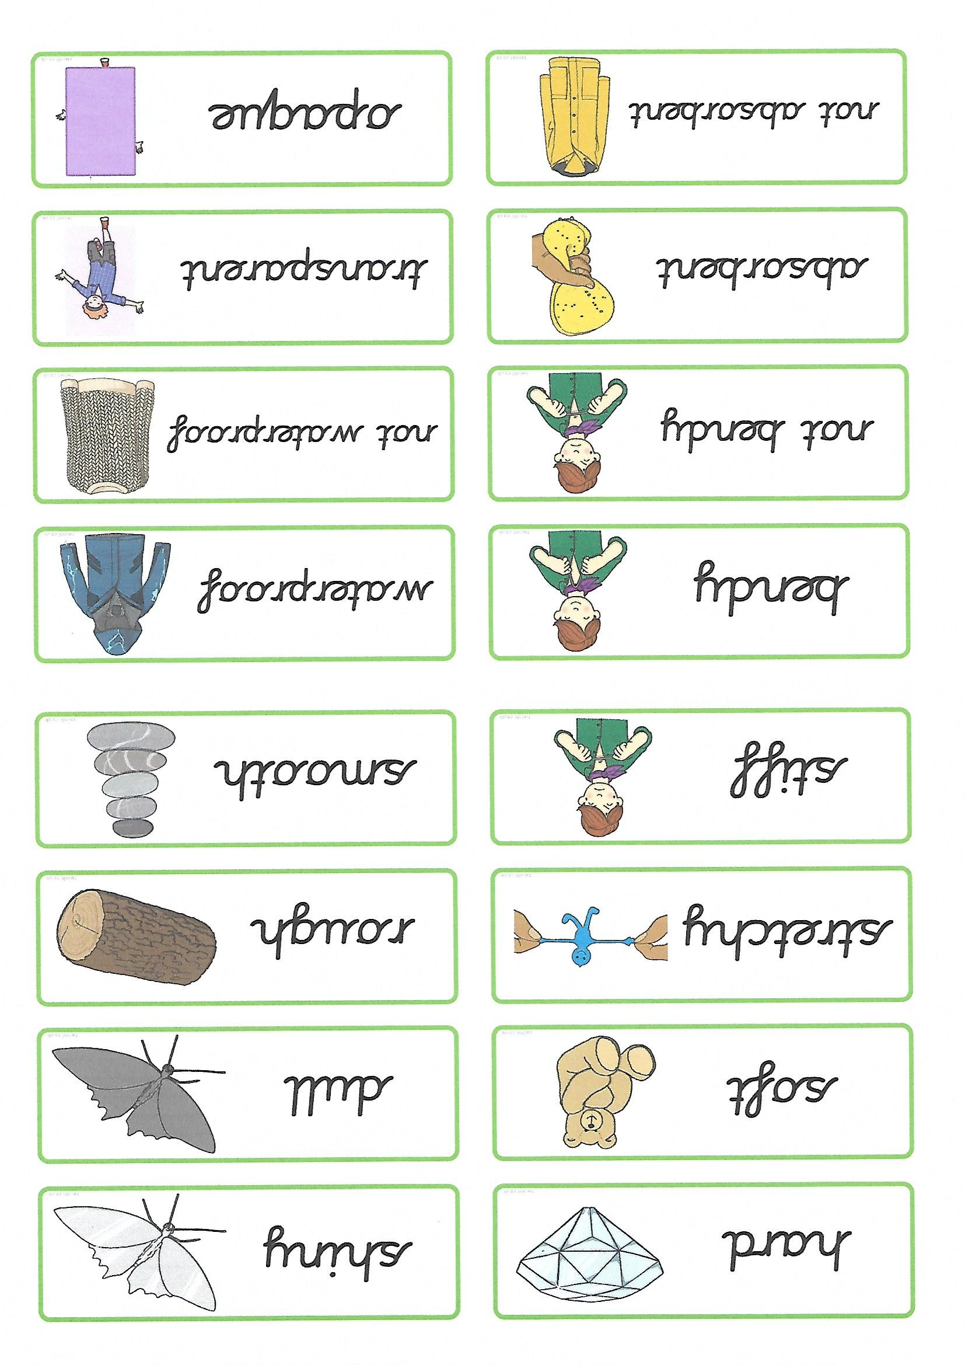

Leaky tent roof

