|  |  |  |
| --- | --- | --- |
| St Julie Catholic Primary School - Art | | |
| ART – SUMMER Term | Year: 5 | **Unit Title: Drawing/Sculpture- Human form** |

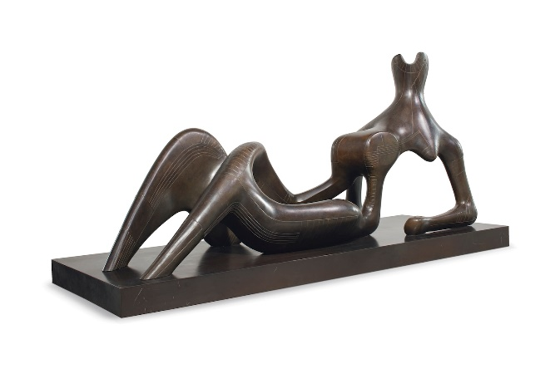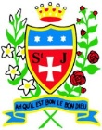

**Barbara Hepworth**

**Vocabulary**

What should I already know?

* I can draw a selection of natural objects from direct observation.
* I can produce an accurate drawing from direct observation of a subject.
* I can express texture in my drawings by making different marks with pencils, pastels and charcoal.I can consider light, tone and negative space in my drawing.
* I can consider scale and proportion in my drawings.

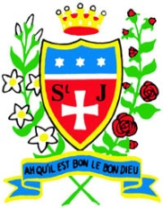

**Organic-**

**natural**

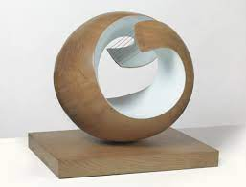

**Henry Moore**

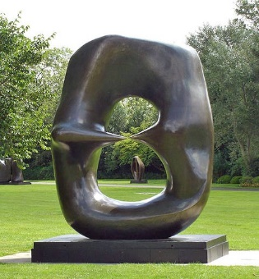

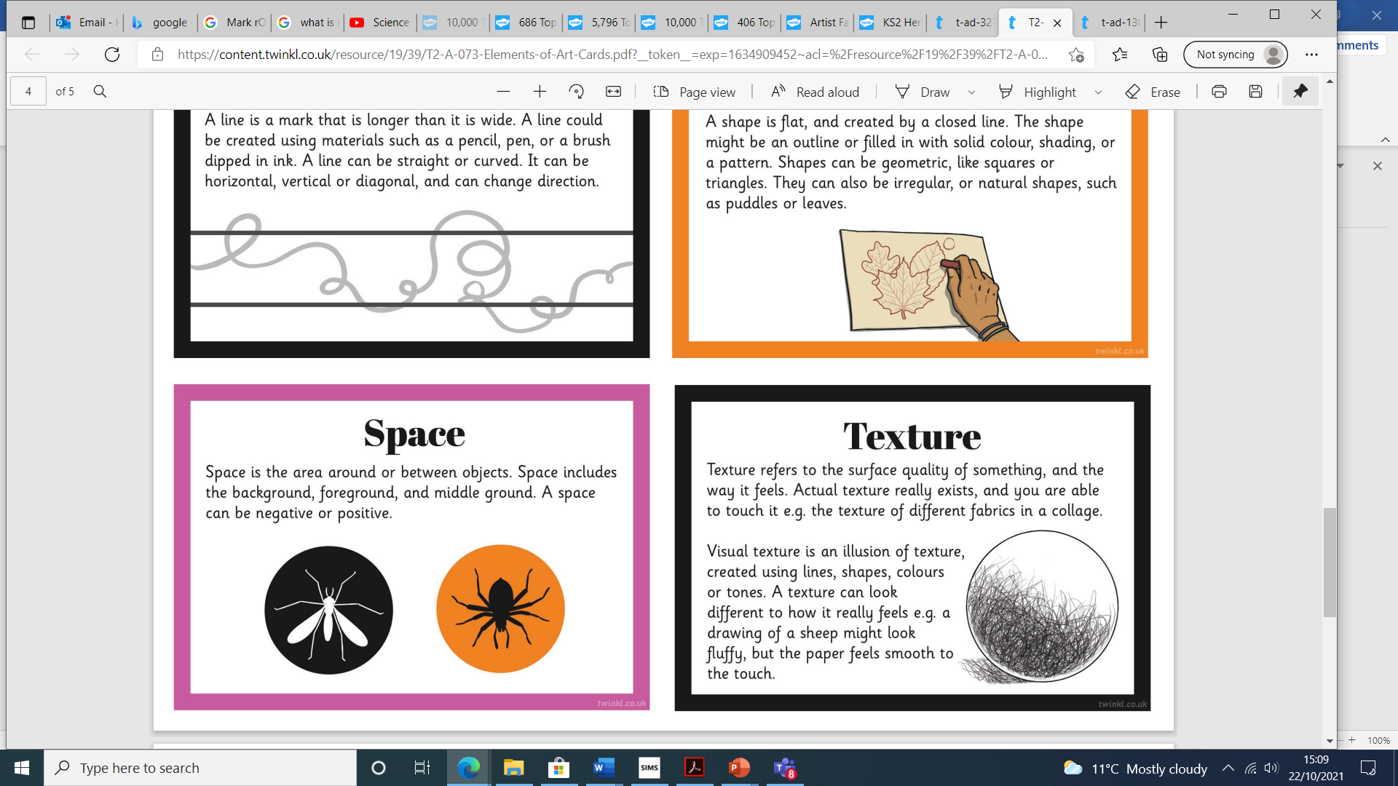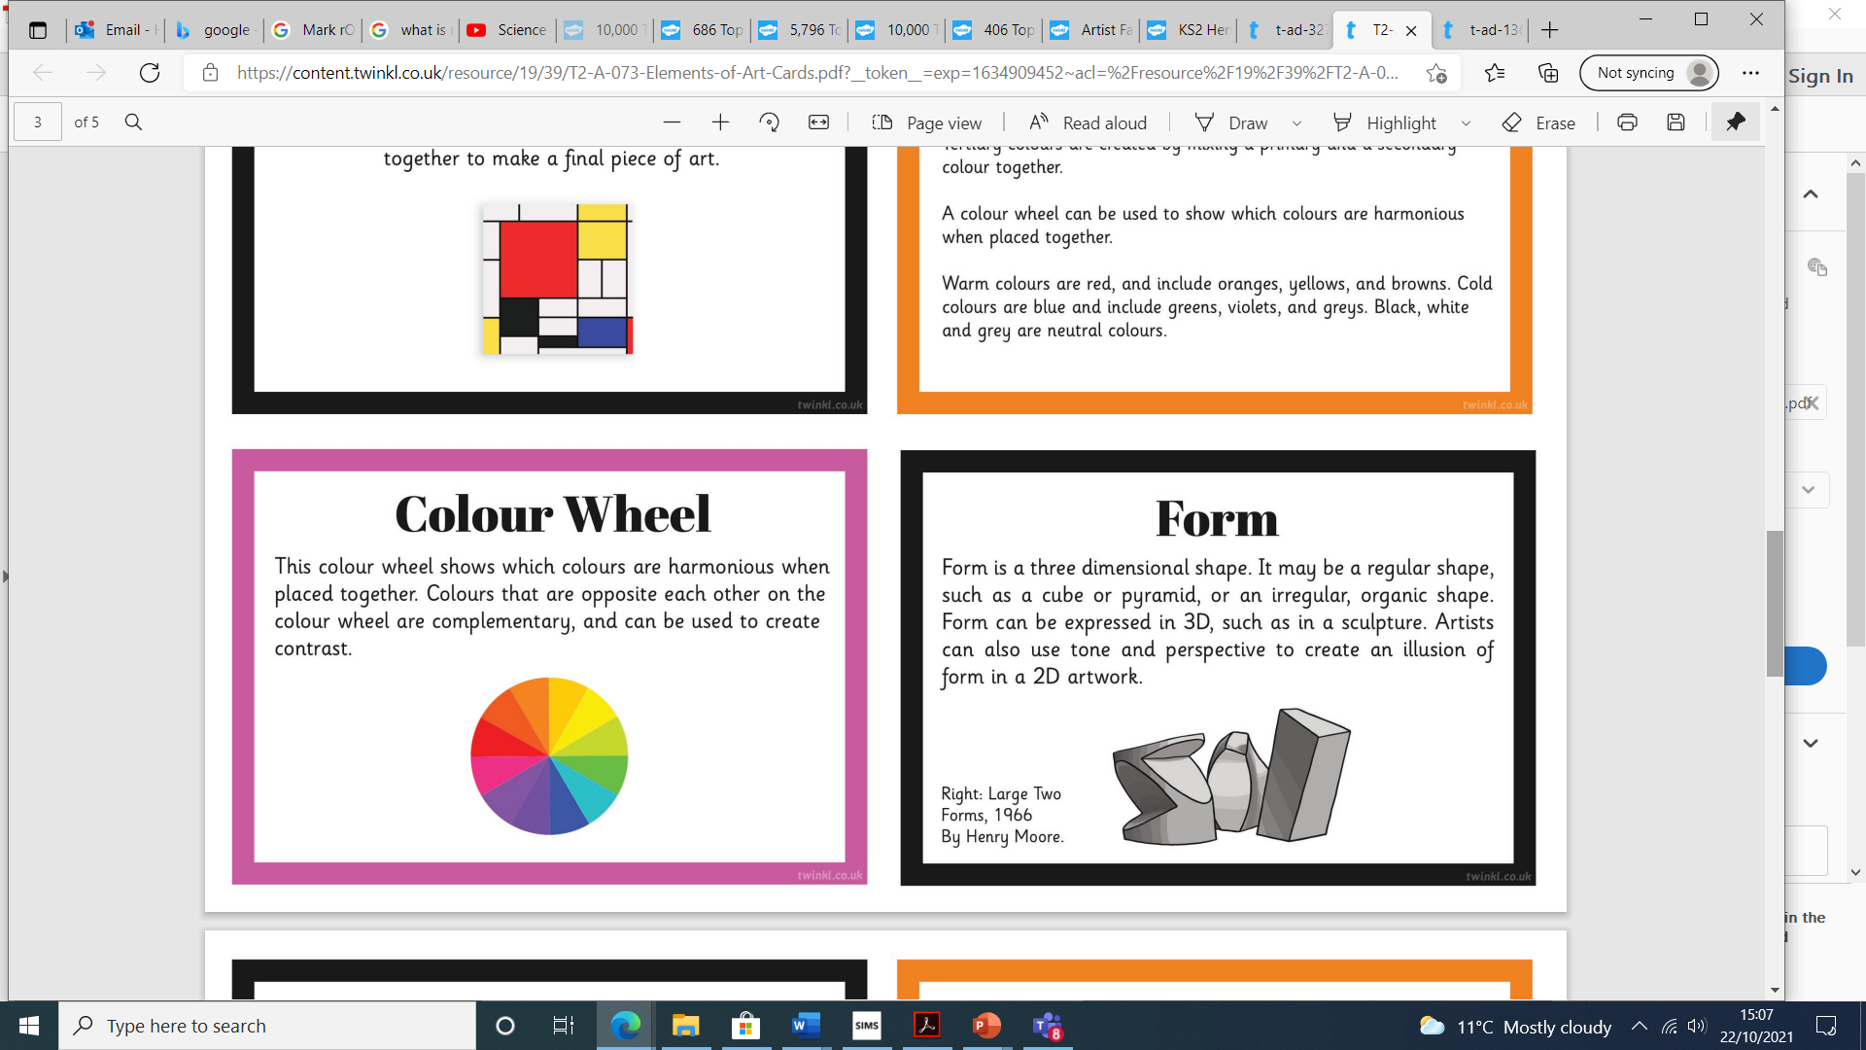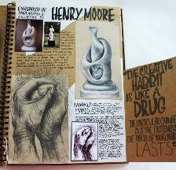

**How do I create sculptures like Henry Moore and Barbara Hepworth?**

I can:

* Research Henry Moore and Barbara Hepworth.
* Experiment with mark making- light/shadow/tone.
* Create ‘balloon’ outline drawings from tracing paper and photographs of children.
* Experiment with clay

pieces-surface texture

marks.

**Abstract**

**Negative Space**

This art work links with my work in Science – The human timeline.

**Henry Moore 1898-1986**

British artist known for his sculptures most of which were made from bronze. During the Second World War, he created many sculptures. These included ‘Women and Children in the Tube’, showing people taking shelter during an air raid and ‘At the Coal Face: A Miner Pushing a Tub’, showing the vital work of miners during the war. Moore worked in stone, bronze and other materials.

**Barbara Hepworth 1903-1975**

Barbara was part of the **modernism movement** – a group who wanted to experiment with new techniques and draw attention to the process involved in making a work of art. She is one of the most famous women artists and is known all over the world. She is known for her modern sculptures, made from stone, wood and bronze.



