|  |  |  |
| --- | --- | --- |
| St Julie Catholic Primary School - Art | | |
| ART – Autumn Term  What should I already know?   * I can recognise Primary colours and use them to mix Secondary and Tertiary colours. * I can use different painting techniques in my artwork. * I can use coloured pencil and/or paint in my artwork with control. * I can blend colours effectively. * I can carefully select colours to use * I can use vibrant colours to create an abstract artwork | Year: 5 | **Unit Title: Colour/drawing Colour- Earth and Space** |

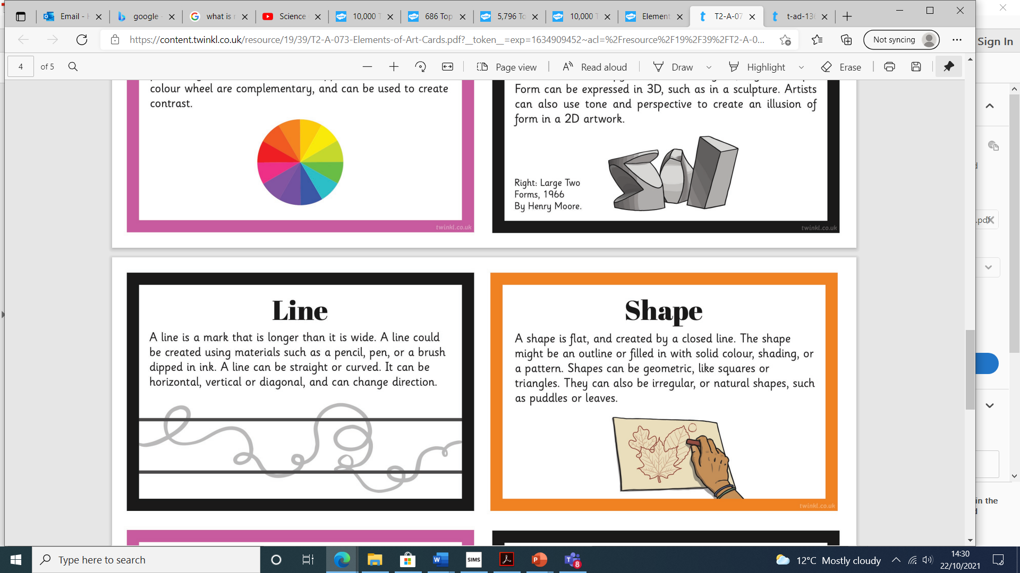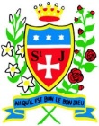

**Vocabulary**

**Van Gogh**

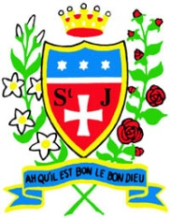

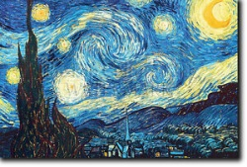

**Mark Rothko**

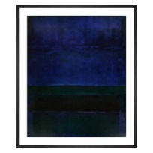

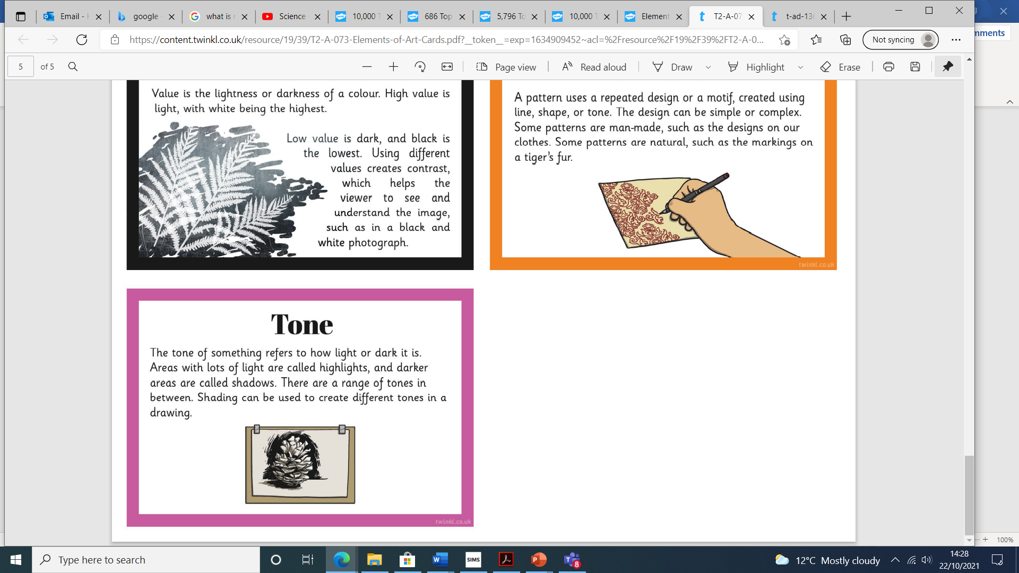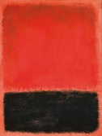

**Van Gogh 1853-1890**

* Dutch artist.
* He painted **portraits** and **landscapes**.
* He used **watercolours** and oil paints.
* Famous for using bright colours and bold brushstrokes.
* Painting style: **Post-Impressionism**.

**Mark Rothko** **1903-1970**

* Born in Russia in 1903
* Moved to America when he was 10.
* Used colour to show his feelings
* Painted in simple blocks and lines on very big canvases.
* This kind of painting was called ‘Colour Field’.

This art work links with my work in Science – Earth and Space

**How do I create paintings like Van Gog**

**and Mark Rothko ?**

I can:

* research pages- Van Gogh and Mark Rothko. Background, pieces and comparison.
* Explore colour mixing inc colour wheel- warm/cold.
* Experiment with different ways of applying the paint to the paper- cardboard, rollers, thicker/thinner and paper texture.
* Make observational drawings/paintings of spheres, concentrating on light and tone.
* Research planet and space - sketches- pastels/chalks.



