|  |  |  |
| --- | --- | --- |
| St Julie Catholic Primary School - Art | | |
| ART – Autumn Term | Year: 5 | **Unit Title: Colour -North America**   |  |  | | --- | --- | | Vocabulary | | | Post impressionism | What you might see if you get a glimpse of an object. Often ordinary, every-day items. | | Abstract | It has colour, lines and shapes (form), but they are not intended to look like objects or living things. | | Pop art | Pop art is a style of art based on simple, bold **images** of everyday items, such as soup cans, painted in bright colours. | | Collage | Involves pasting items like leaves or photographs onto a sheet of paper | | Relief | A relief is formed when a **three-dimensional effect is raised from a flat base**. | |

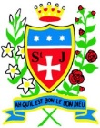

What should I already know?

* I can recognise Primary colours and use them to mix Secondary and Tertiary colours.
* I can use different painting techniques I can use coloured pencil and/or paint in my artwork with control.
* I can blend colours effectively.
* I can carefully select colours to use
* I can use vibrant colours to create an abstract artwork.

**Jasper Johns**

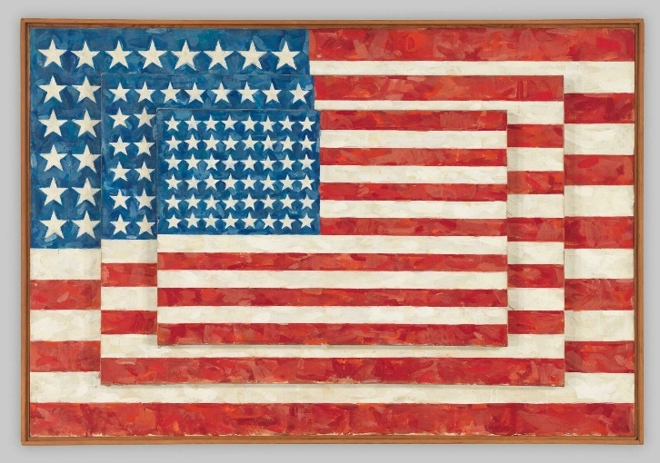

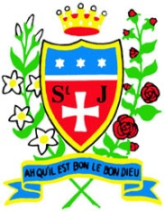

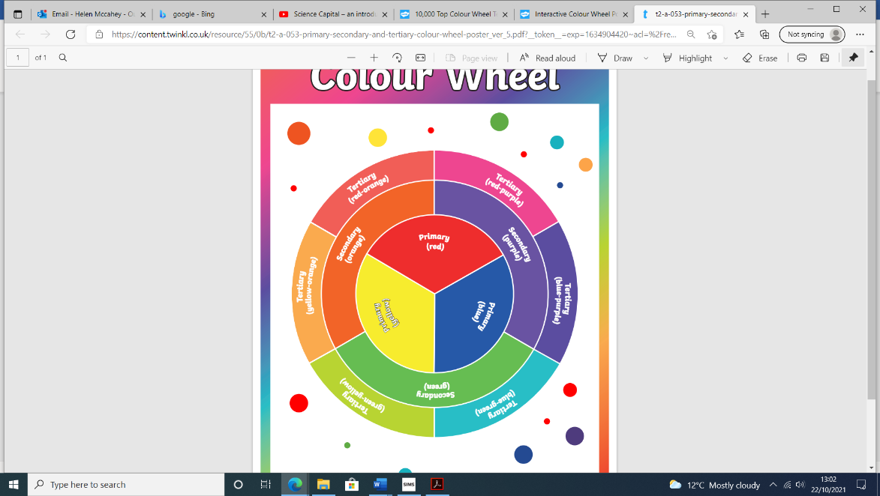

This art work links with my work in Geography – North America and the USA.

**Jasper Johns, born 1930**

**Art movement:**

**Abstract Expressionism Pop art**

**Post impressionism**

* American artist
* Painted items linked to the USA- Map and flag of USA
* Materials he used: oil, encaustic, ink, collage and relief

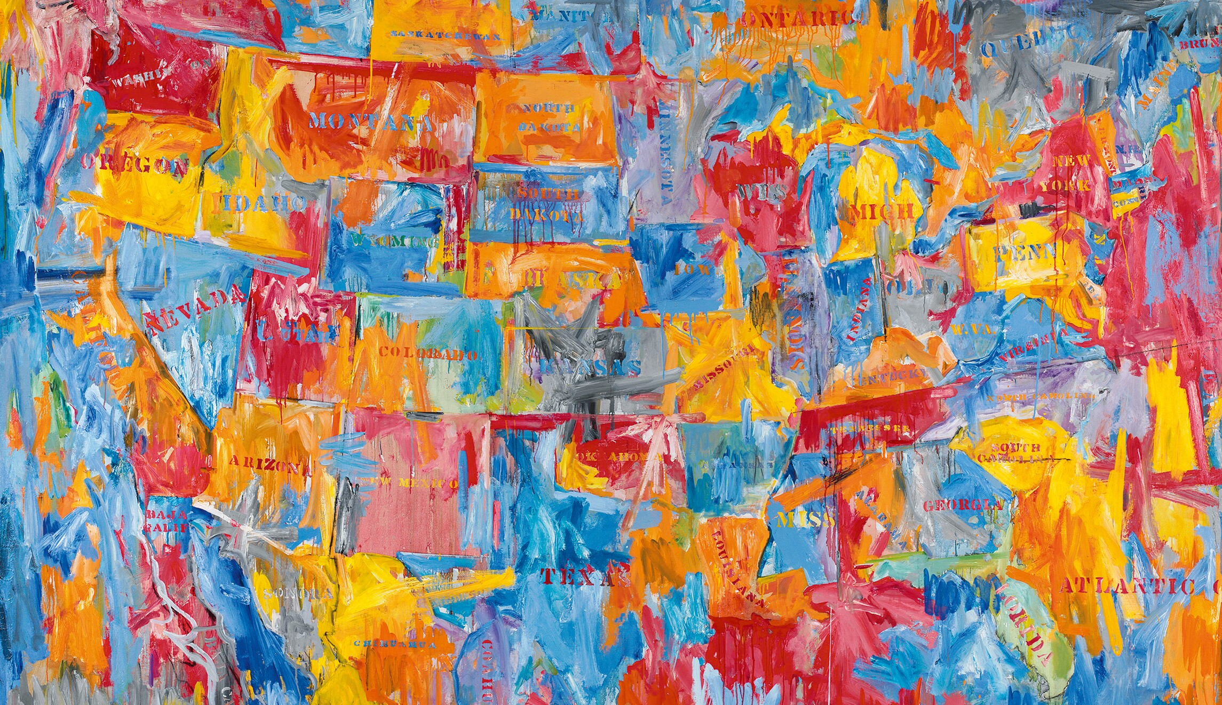

I know and can create:

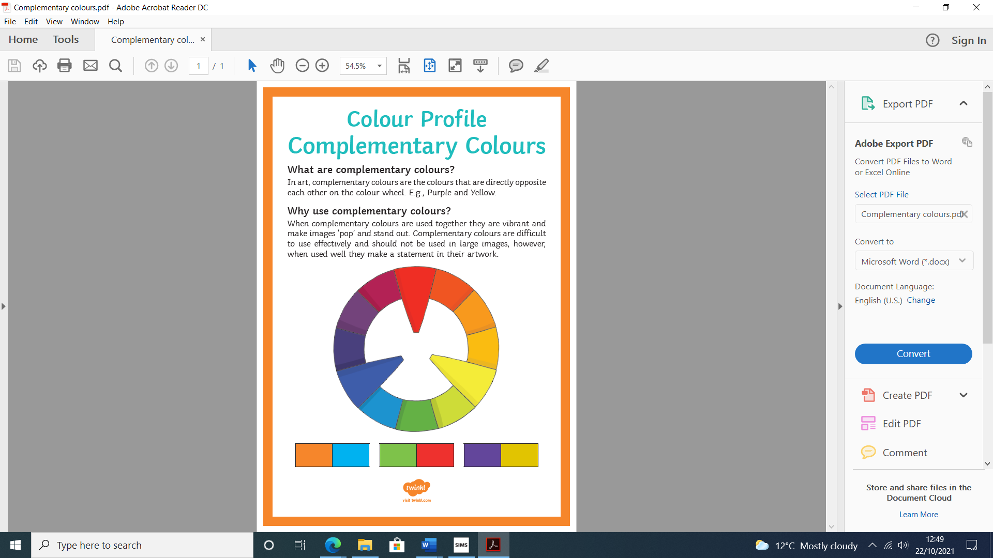

.

**How do I create paintings like Jasper Johns?**

I can:

* research Jasper Johns, different flags and their meanings.
* Explore colour mixing inc colour wheel- complimentary colours.
* Experiment with different ways of applying the paint to the paper- cardboard, rollers, thicker/thinner and flat/texture.
* Design flags with different colour combinations, including symbolism.

**Complementary colours** are the colours that are directly opposite each other on the colour wheel. E.g., Purple and Yellow.

When complementary colours are used together they are vibrant and make images ‘pop’ and stand out.



