|  |  |  |
| --- | --- | --- |
| St Julie Catholic Primary School - Geography | | |
| Why visit North America? | Year: 5 | Strand: Human and Physical Geography |

[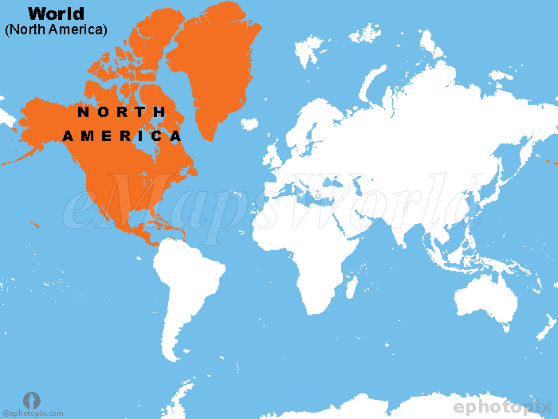](http://www.emapsworld.com/north-america-location-map.html)

**Sticky knowledge**

Lines of latitude and longitude are used to locate places accurately on the Earth’s surface

Canada, the USA and Mexico are countries in N America



**UNITED KINGDOM**

**What should I already know?**

* I live in Eccleston, St Helens, which is in Merseyside
* Eccleston is in England, which is a country in the United Kingdom, in the continent of Europe
* There are seven continents including North America

[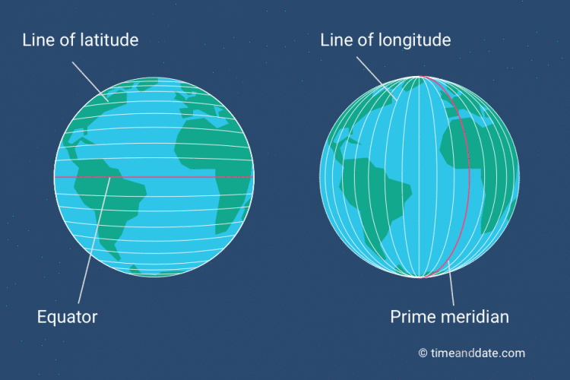](https://www.google.co.uk/url?sa=i&rct=j&q=&esrc=s&source=images&cd=&ved=2ahUKEwjH96u0stbmAhViAGMBHT2jCmwQjRx6BAgBEAQ&url=https://www.timeanddate.com/geography/longitude-latitude.html&psig=AOvVaw2TxfGCBLIuszUe_iskRnhO&ust=1577555500858900)

**Vocabulary**

|  |  |
| --- | --- |
| **Canyon** | A deep valley, cut by a river through rock |
| **Climate** | The average weather of an area over a long period of time |
| **Continent** | A large area of land – it may consist of one or more countries |
| **Latitude** | Lines that circle the Earth in a East – West direction |
| **Longitude** | Lines running from the top of the Earth to the bottom |
| **Settlement** | A place where people establish a community |
| **states** | Areas of land in a country that have different laws. The USA has 50 states |
| **Tourism** | is travel for pleasure; also the business of attracting, accommodating, and entertaining tourists. |

**What will I learn during this unit?**

* I will know the names some of the countries of North America including Canada, the USA and Mexico
* I will know the names of, and identify, different biome zones in North America
* I will explain, name and use lines of latitude and longitude
* I will know some of the major human and physical features of North America
* I will know some reasons why tourists visit the Rocky Mountains
* I will know that there are different time zones
* I will compare/ contrast aspects of New York State and St Helens.

The Rocky Mountains stretch 3,000 miles from Canada to New Mexico in the U.S.A.

Geography Skills

I can use latitude and longitude to locate places on a map.

I can identify the key human and physical features of a locality