St Julie Catholic Primary School – Geography Y5
Topic: Why is Fair Trade fair? | Year: 5 | Strand: Economic activity and trade links
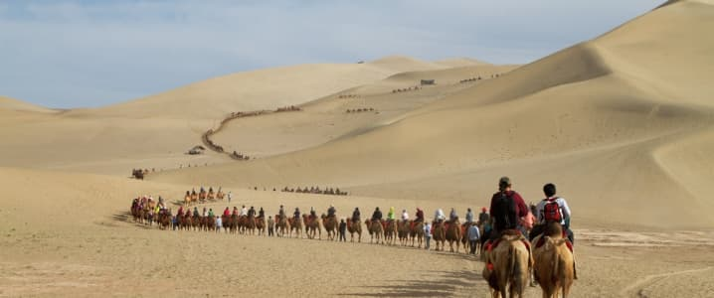
What should I already know?
- Rivers are trade routes
- Liverpool is a port

“Sticky knowledge” to remember:
Locate China and UK on world maps:

Know that Marco Polo was an Italian
merchant and trader who travelled
the Silk road. He was one of the first
Europeans to travel into China.
1254-1324
Know that the ‘Silk Road’ was a major trade route.

Know that Southampton and Liverpool are ports.

Know that the UK imports more from China than any other country in the world.

Recognise and explain the
meaning of the Fairtrade symbol.

The Silk Road
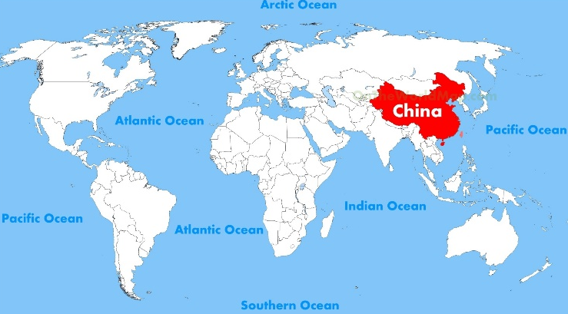
UNITED KINGDOM
I will use geographical skills:
- Use maps, atlases, globes and digital/computer mapping to locate countries and describe features studied.
- Use the eight points of a compass, four and six-figure grid references, symbols and to build knowledge of the UK and the wider world.

By the end of this topic I will be able to:
- Explain why and how countries trade with each other
- identify and describe the commodities that are most frequently traded
- evaluate some benefits and disadvantages of trading
- Compare and contrast the range of commodities most commonly imported/exported between the United Kingdom and China
- Describe, explain and reflect on why international trade is not always fair
- evaluate and judge the benefits to be gained from Fairtrade
- Understand what the ethical production and purchasing of clothes entails
- evaluate and reach a judgement regarding the practice of popular clothing companies.

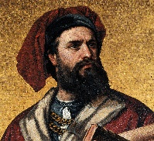
Vocabulary
Consumer | Person who buys goods
Country of origin | Country where goods were made
Export | Send goods to another country
Import | Bring goods into a country
Fair trade | Producers are paid a fair price for their goods
Producer | Person/business that makes/produces goods for sale
Raw material | Basic material from which a product is made
Retailer | Person/business that sells goods/services
Sustainable | Not harmful to the environment/ resources can be replaced
Trade | Buying/selling goods

