St Julie Catholic Primary School - History
Why are there WWI graves in Eccleston? | Year: 5 | Strand: Local History
Vocabulary
Local history | The history of our local area – Eccleston and St Helens
Primary Source | A piece of evidence from the time we are studying
Secondary source | Evidence that has been copied or told to another person
PALs battalions | Groups of friends who joined the army together
The Front | Where the fighting took place
Trenches | Ditches stretching for many kilometres, where soldiers would fire at the enemy and prepare for attack
No-Mans land | The land between opposing armies
Propaganda | Tricking a person into thinking a certain way.
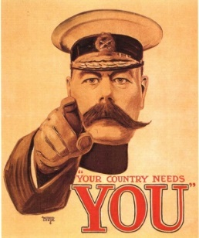
What should I already know?
Knowledge of what a war is - Florence Nightingale/ Mary Seacole (Crimean War) Edith Cavell (WWI)

Local History - Samuel Taylor paid for Christ Church to be built and used sandstone from the quarry in Taylor Park.

Knowledge of Remembrance/poppies from celebrations in school each year.

History Skills
I can identify primary and secondary historical sources
I can use a variety of sources to draw conclusions
1914
1915
1916
1917
1918
Assassination
Franz Ferdinand
June 28

Britain declares war
on Germany August 4

Armistice – fighting stops
November 11

Battle of Somme
July

Sinking of the Lusitania-
America enters the war May

Battle of Verdun
February

Battle of Passchendaele
(pash-en-dale)

Christmas Truce
December 24th

Sticky knowledge

- Know some of the propaganda – posters/ poems- which prompted men to join the army
- Know the key causes of WW1
- Know key dates identified on the timeline below.
- Know key combatants:
Triple Alliance = Germany, Austria-Hungary, Italy
Triple Entente = Britain, Russia, France
- Describe life/ conditions in the trenches

What I will learn during this unit?

- Link Eccleston to WW1 events
- Use databases to find information about local war graves
- EVALUATE photographs, diaries, letters museum artefacts and the locality to find out about Eccleston/St Helens and WW1
- EVALUATE EVIDENCE and REACH INFORMED CONCLUSIONS about life in the trenches
- Place some key events of WW1 in chronological order and link with Eccleston
- Place WW1 within a CHRONOLOGY of key world events

