St Julie Catholic Primary School - History
Topic: What changes happened in Britain from the Stone Age to the Iron Age?  What should I already know?  - changes from Stone Age to Iron Age | Year: 3 | Strand:
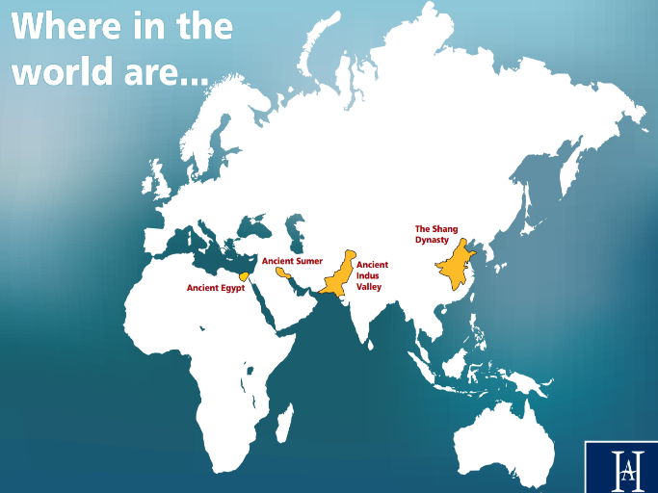
Vocabulary
Chronology | The arrangement of events or dates in the order of their occurrence
Civilisation | Human society which is organised.
Dynasty | A series of rulers or leaders who are all from the same family, or a period when a country is ruled by them.
Empire | A group of countries ruled by a single person, government or country.
Kingdom | A place ruled by a king, queen or important person
Artefact | An object made by human beings, using with historical interest.
Location | A place or position.
River valley | A long area of low land between mountains or hills with a river running through it.
Achievements | something achieved through hard work, courage, or skill.

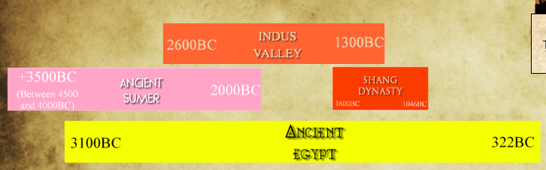
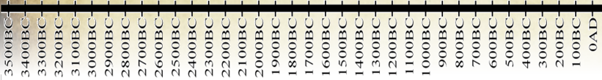
The four ancient civilisations started at different times and were of different durations, BUT there is one period of time when all were building cities and their civilisations at the same point in time.

They are all on the same line of latitude.

They all grew alongside a river.

History skills
I can

Civilisation
Ancient Sumer - Began about 6,000 years ago. Earliest known civilization in the area that is now southern Iraq.
Indus Valley - One of the first large civilisations. Began nearly 5,000 years ago in an area of modern-day India and Pakistan
Ancient Egypt- Began 5,000 years ago when people started building villages next to the River Nile in north-east Africa
Shang Dynasty - An ancient Chinese civilisation from over 3,500 years ago.
Achievements
Ancient Sumer – wheel for a chariot

Indus Valley- the city of Mohenjodaro, with its grid pattern of the main streets.
Ancient Egypt - irrigation systems, pyramids and mummies.
Shang Dynasty – Jade and silk.

Sticky Knowledge
What will I learn during this unit?
1.When did the four ancient civilisations exist?
2. Where in the world were they?
3. What great achievements or inventions did they create?
4. How have they influenced our lives today? 5. How do we know about these civilisations? 6. What are the countries and people called who live in these areas now?

