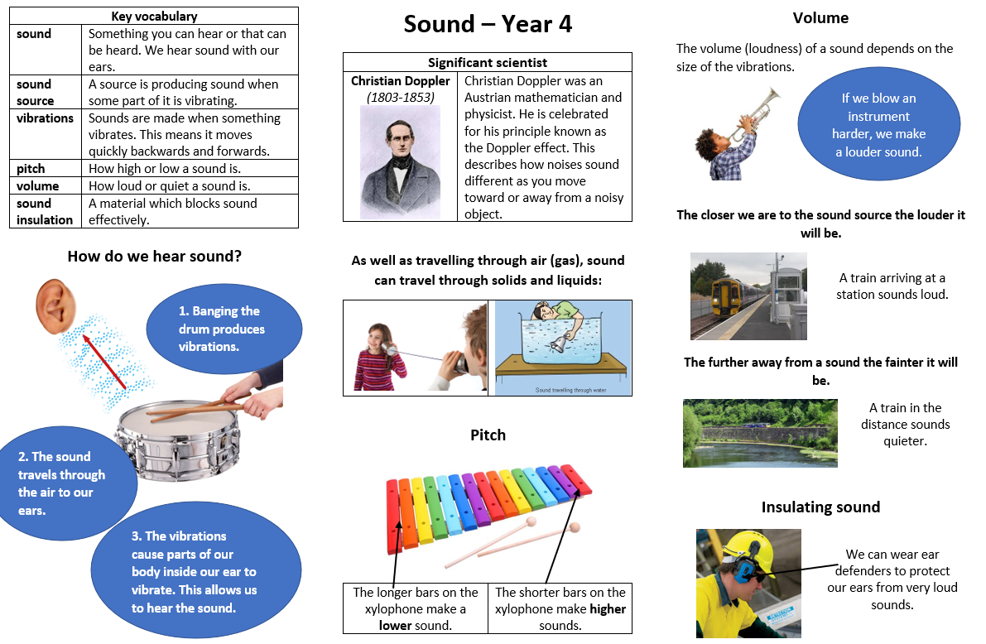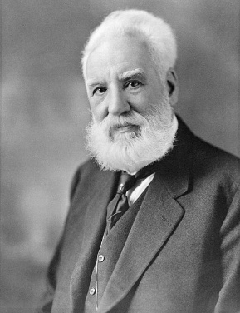

**Scientific skills**. I will: make observations, make predictions, plan for investigations, look for patterns, ask questions.

**What I will learn in this topic:**

• Know how sounds are made, associating them with vibrating.

* Know how sound travels from a source to our ears.

• Know what happens to a sound as it travels from its source to our ears.

• Know the link between:

1. the volume of a sound and the strength of the vibrations that produced it.
2. pitch and the object producing a sound.

**Sticky knowledge:**

* **Know** that sound travels from its source in all directions and we hear it when it travels to our ears.
* **Know** sound travel can be blocked.
* **Know** sound spreads out as it travels.
* **Know** changing the shape, size and material of an object will change the sound it produces.
* **Know** sound is produced when an object vibrates.
* **Know** sound moves through all materials by making them vibrate.
* **Know** changing the way an object vibrates changes it’s sound.
* **Know** bigger vibrations produce louder sounds and smaller vibrations produce quieter sounds.
* **Know** aster vibrations (higher frequencies) produce higher pitched sounds
* Born Edinburgh, Scotland
* Invented the first practical telephone
* He became interested in sound because his mother was losing her hearing.

**Alexander Graham Bell**

**1847-1922**

**I already know**

* that objects make different sounds.
* that I use ears to hear sounds.
* In music, different instruments make different sounds
* I can change the volume of a sound