St Julie Catholic Primary School – Science
Topic: Animals including Humans | Year: 4 | Strand: Biology
Sticky Knowledge to remember:
The main parts of the digestive system:
- Food enters the body through the mouth
- The teeth start to break the food down. Saliva is added and the tongue rolls the food into a ball.
- After swallowing, the food passes down the oesophagus to the stomach
- In the stomach the food is broken down further by being churned around and some chemicals are added.
- Food passes into the small intestine. Here nutrients are removed from the food to be used elsewhere in the body.
- The rest passes into the large intestine where water is removed to be used elsewhere in the body.
- What is left is then stored in the rectum until it leaves the body through the anus when you go to the toilet.
Teeth
Humans have 4 types of teeth:
- incisors – used for cutting
- canines – rip and tear food
- molars and premolars – for grinding and chewing food

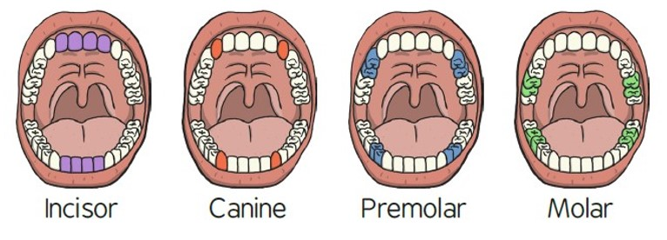

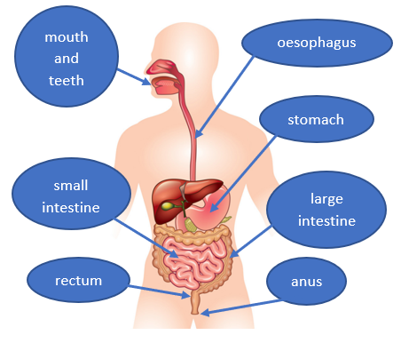
What should I already know?
- The parts of the human body and what they do.
- All animals need water, air and food to survive.
- The different ways in which humans are healthy.
- Animals get nutrition from what they eat. Humans and some animals have skeletons and muscles for support, protection and movement.
- What carnivores, omnivores and herbivores are. Excretion is one of the seven living processes.
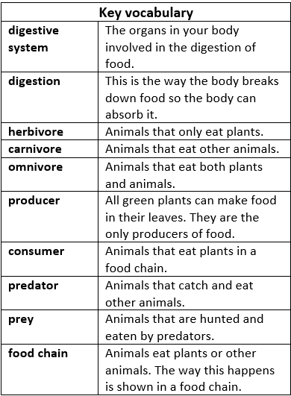

In this topic I will learn:
• Teeth are used for cutting and chewing food.
• They start the digestive process which gives us the energy we need to live.
• Humans look after their teeth by brushing and flossing and ensuring that they do not eat foods high in sugar.
Not looking after teeth can lead to an increase in plaque and tooth decay.

In investigations I will:
- Identify fair tests
- Identify and use variables
- Make predictions
- Repeat measurements for accuracy
- Ask scientific questions
- Build scientific models to help answer questions

