|  |  |  |
| --- | --- | --- |
| St Julie Catholic Primary School - Art | | |
| ART – Autumn Term | Year: 6 | **Unit Title: Water Collage** |

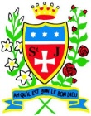

|  |  |
| --- | --- |
| Vocabulary | |
| **Collage** | **Art created by combining photos, materials, clippings or small objects onto a surface.** |
| **Textured** | **Materials that are rough or uneven surface or consistency.** |
| **Layering** | **Materials on top of each other** |
| **Combine** | **Join or merge materials.** |
| **Perspective** | **3 or 2 dimensional.** |

What should I already know?

* I can create a collage using drawings,

text and photographs.

* **Vocabulary** - Direct observation, accurate, proportion, scale, perspective, layering, combination, depth.

**Katsushika Hokusai and Matthew Cusick**

**Water Collages**

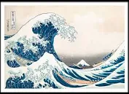

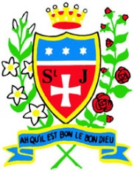

**Skills recap:**

* How to cut/tear materials accurately and the different effects achieved by each.
* Which materials work effectively together.
* How text impacts the viewer/adds

meaning and provides thinking.**Art Skills**

* Can I cut and tear materials with accuracy?
* Can I combine different materials effectively in one artwork?
* Can I add text to my design?
* Can I create a representation of a subject using collage?
* Can I convey meaning through collage?

**Curriculum links:**

Geography - What is a river? DT - Materials.

**How do I create a water collage?**

1. Research & collect materials that are effective for a water collage.
2. Explore the techniques of the artist.
3. Combine materials that represent water.
4. Select materials that will provide meaning.
5. Photograph & display your finished collage.

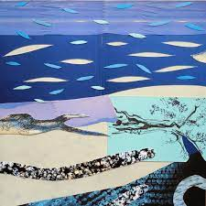

**Katsushika Hokusai and Matthew Cusick.**

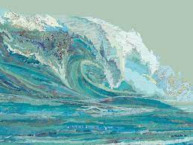 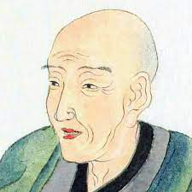

* Cusick is an American artist born 1970.
* He is a multi-media artist.
* He is best known for his map collages and intricate portraits of landscapes.
* Hokusai is a Japanese artist.
* His prints were formed by wood block printing techniques.
* His art contains views of Mount Fuji which includes the internationally iconic print The Great Wave off Kanagawa.



