|  |  |  |
| --- | --- | --- |
| St Julie Catholic Primary School - Art | | |
| ART – Spring Term | Year: 6 | **Unit Title: Drawing - Narratives** |

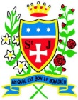

|  |  |
| --- | --- |
| Vocabulary | |
| **Monochromatic** | **Containing or using only one colour.** |
| **Blending** | **Intermingling two or more colours to create a gradual transition or to soften lines.** |
| **Angular** | **Sharpest angle formed in drawing, two edges that meet.** |
| **Illustrative** | **Depiction made by an artist.** |
| **Graduated** | **Transitioning from one colour hue to another.** |

What should I already know?

* I can consider scale and proportion in my drawings.
* I can create an effective composition.
* I can understand perspective and express it in my drawing.
* I can consider light, tone and negative space in my drawing.

**Pieter Bruegel the ElderDrawing – Narratives**

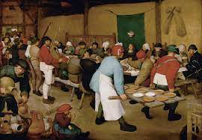

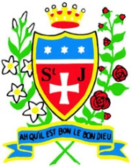

**Skills recap:**

* How to consider the layout and design of a narrative drawing.
* How to apply all skills learnt to drawings.
* How to select key themes from a story or play and interpret them into one artwork.
* How to convey narrative in a drawing

**Art Skills**

* Can I consider narrative in my drawings?
* Can I interpret written stimulus into visual imagery?
* Can I explore a theme or subject imaginatively?
* Can I create an effective composition?

**Curriculum links:**

History - Aspects of life from 1066. PSHE – Cultures, Work & Life.

**How do I create a narrative drawing?**

1. Research & discuss the themes of the narratives of the artist.
2. Select & explore the art of the narrative.
3. Compose a narrative drawing using the skills studied.
4. Refine and develop my narrative.
5. Display and review my narrative.

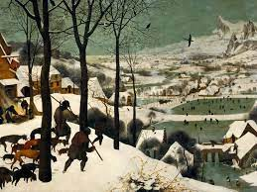

**Pieter Bruegel the Elder**

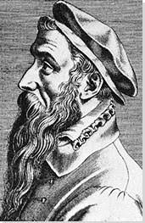 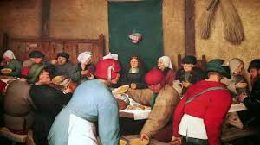

* The Peasant Wedding is a 1567 genre painting by the Dutch and Flemish Renaissance painter and printmaker Pieter Bruegel the Elder.
* He enjoyed painting peasants and different aspects of their lives in his paintings.
* Many of his paintings have a symbolic meaning as well as a moral aspect.
* His paintings show us about life at that time.
* His medium was oil on panels.



