St Julie Catholic Primary School – History
Where the Vikings Vicious or Victorious? | Year: 6 | Strand: The Viking and Anglo Saxon struggle in England.
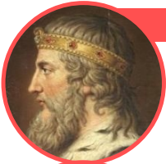
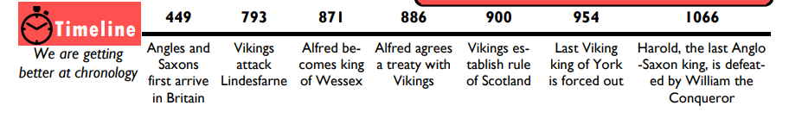
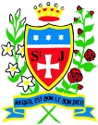
Where Vikings explored.
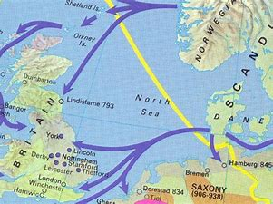
Alfred the Great
What will I learn during this topic?
- To be able to understand who the Vikings were, where they come from, why and how?
- To explain what the Viking raid on Lindisfarne reveals about Vikings.
- To discover why Vikings conquered Jorvik.
- To explain Danelaw and the treaty between the Anglo Saxons.
- To explore Vikings who were not warriors.
- To evaluate whether Vikings were vicious or victorious.

Sticky Knowledge
- _________Vikings came in peace.
- The lands the Vikings occupied the lands of ______________ _____________ _________ in Danelaw.
- Not all Vikings were berserkers or wore horned helmets.
- Vikings were pagans and they raided monasteries because ___________

What should I already know?
- Facts about the Anglo Saxons
- Facts about Alfred The Great
- Time/era for the Anglo Saxons
History skills
I can make reasoned judgements using the Viking evidence.
I can evaluate whether Vikings were vicious or victorious.
Vocabulary
Raids | A sudden armed attack, the aim is damage and plundering not settlement.
Berserker | Warriors sent to war wearing bear skin. Sent out first to charge & attack fiercely – or go Berserk.
Vicious | To be intentionally harmful or nasty. Some Viking warriors were fierce.
Dane Law | The name given to the lands in Britain and rules used when occupied by the Vikings.
Misconception | A misunderstanding or wrong image of Vikings.
Chronicle or Saga? | A record of events in order that they happened. A long story of episodes or adventures from Norse history.
Long ships | A narrow boat Vikings used to raid or trade.
Treaty | A law or agreement between people.

