|  |  |  |
| --- | --- | --- |
| St Julie Catholic Primary School – History | | |
| How have historic medical breakthroughs affected our lives today? | Year: 6 | Strand: Post 1066 Study |

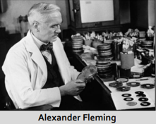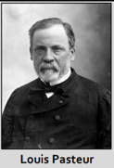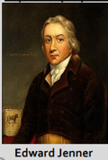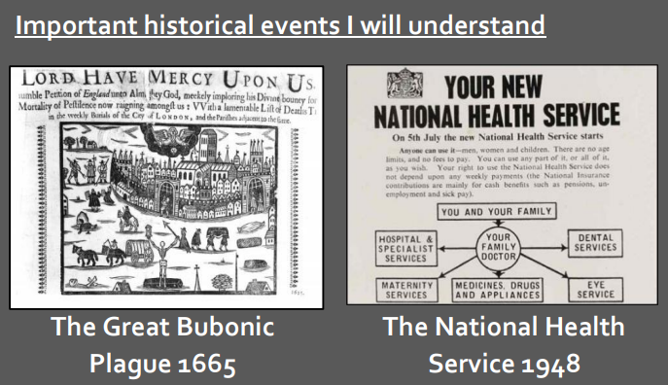

**Sticky Knowledge**

Families in Britain gained Grandparents for the first time around 11,000 years ago.

In 1840 life expectancy in Britain was still only 40 years because

* Medical knowledge was limited.
* Living conditions and sanitation were bad.
* Work for most was physically and dangerous.
* In towns and cities air was heavily polluted.
* There were lots of overseas and civil wars.

People thought the plague was a punishment from God or that it was spread through bad smells in the air.

Edward Jenner’s discovery of the smallpox vaccine saved more lives than any other discovery so far in history.

Louis Pasteur discovered that germs called bacteria cause infection.

Alexander Fleming made the first antibiotic.

**History skills**

I can describe and explain what the term ‘life expectancy’ means.

I can explain and justify my ordering of the main milestones in the history of medicine in Britain.

**What should I already know?**

-How people lived in the Stone Age

-The Great fire of London was in 1666. - Florence Nightingale was a nurse during the Crimean War and how she changed the hospitals.

**What will I learn during this unit?**

1. What the term ‘life expectancy’ means.
2. Why life expectancy in Britain remained low until the 1800s
3. The cause of the Great Bubonic Plague of 1665. How people at the time felt the plague could be prevented and treated. Why the plague spread so rapidly.
4. The significance of what Edward Jenner discovered in 1796. Why many people opposed the use of smallpox vaccinations.
5. The major medical milestones of the last 250 years. Create a timeline to show these milestones. Decide which of these developments were the most significant

|  |  |
| --- | --- |
| **Key Vocabulary** | |
| Disease | an illness or sickness with symptoms that prevent the body functioning |
| Sanitation | having clean drinking water and a system of disposing of sewage safely |
| Hygiene | cleanliness to maintain health and prevent disease |
| Epidemic | an infectious disease that spreads over a very wide area |
| Bacteria | microscopic germs that can cause disease |
| Virus | microscopic parasites that cause disease and are not killed by antibiotics |
| Antiseptic | something that kills or prevents the growth of bacteria. |
| Antibiotic | A medicine that will search out and destroy bacteria in the body |
| Vaccination | creating immunity to disease through injecting someone with a weakened or killed bacteria or virus |
| Life expectancy | the average number of years that a person is likely to live for |
| Superstition | a belief based more on fear of the unknown than information |