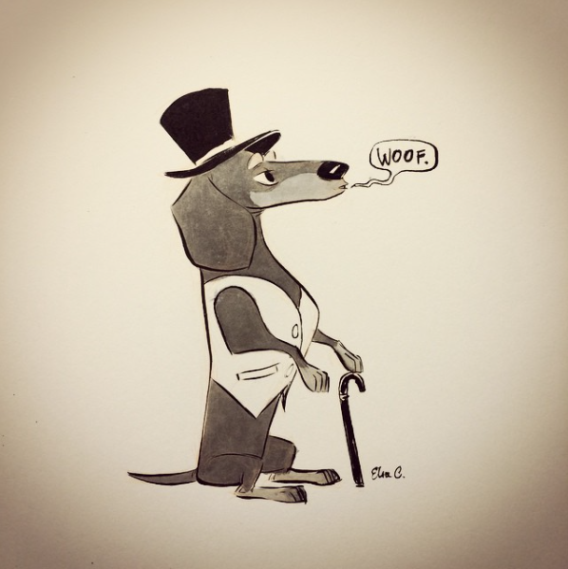
Once upon a time, there was a dog called Bagel. He was a sausage dog who had a dream. A dream to be fancy and own a business. “Hound Inc.” Selling clothes for dogs and other pets were how he planned to make a fortune. Our story begins in his owner’s house. His owner was called Katy, she had brown hair, blue eyes and a HUGE love for beagles, dachshund and any other type of hound. His mum and dad were in the dog beds. Fast asleep. Did I mention his parents were deep sleepers. Oh, I forgot, his sister Bella was in the garden, looking for butterflies. Anyway, let’s get back to our story. As usual, Bagel was staring out the window, hoping that a magic genie would appear out of a lamp and make his dream come true. “Good morning, Bagel” said Katy in her regular good morning mood “Would you like your breakfast?”
“Yes, please” said Bagel. *YAWN* Everyone else was waking up now.
“I’d better get out the window before they start yelling at me” Quickly, he jumped down from the window onto his bed. After breakfast, one at a time, his family went for a walk. First it was Bella, who had come back later claiming that she found a butterfly with a dog face on it. “It’s true” she lied “It really is!!!” Next was mum, when she came back, she boasted that she got a selfiewith Ben German Shepard. After that, it was dad, and unlike his mum and sister he came home normally and perfectly.As he walked in on his teal and gold lead, Bagel thought, “That will be me in the next few years when I have my big business”
Last but not least, it was Bagel’s turn to go for a walk. When Katy asked where he wanted to go, he knew straight where to go because he had a plan. A great plan. A great, risky plan. He was going to run away.When he was let of his lead, he would disappear into the trees and run away. Then he could make his business without anyone stopping him.
When they arrived at the park he had disappeared in the bushes, but he was interrupted with a voice that said “Where you goin’ then” Bagel looked around. He couldn’t see anyone, so he answered “Running away.By the way, what’s your name?” There was a dog coming out of the shadows. “I’m Toni, the terrier” he said “Can I come with you?” Bagel was confused “Why!?”
“Me owners gettin’ old, I don’t do much anymore” he said honestly. As they left the park,he wanted an opinion on his idea. “Toni,” he said.
“Yeah,” he said.
“I want to make a business. One that I can make a lot of money with. Do you think selling clothes for dogs will get lots of money?”
“Well dog coats are getting popular,” he muttered “But maybe selling dog food and other thing as well as the clothes would get more money.” Bagel thought about it. It actually sounded like a good idea. “Ok. But I need help with it. Could you help?”
“Of course, I’ll help!” he exclaimed “and I know a few people who can help. But they are dotted all around the city. So, we can go and find them one by one.”
Toni pulled a map out of the bin next to then and a red and black crayon out of the bush. He started to dot lots of different landmarks around the map of London. “First stop, the top of Big Ben.
About two hours later, they arrived at the queue for Big Ben. “We just need to get past the guards at the entrance” he whispered. Bagel didn’t have a clue what he was talking about. He gave Toni a confused glance and Toni got the idea. “Just follow my lead” he said. They slithered through the legs of busy people when they finally got to the front of the line. Toni slipped under the lady at the front. “C’mon!” he whisper- shouted. Bagel then slipped under her dress too. As she moved into the building, the dogs did too. When they got inside, they slipped out of the dress. “Let’s get up these stairs. No humans take the stair, they take the elevator.”
When they reached the top, there was a vent. Toni lifted the vent’s lid off of it and the crawled along until they reached the end of the tunnel. “Jelly! Jelly and Waffle!” shouted Toni. Two dogs emerged from the shadows. “Who are they?” asked Bagel. Toni pointed to a Shih-Poo and a Miniature Poodle. “Shih-Poo is Jelly. Jelly has a great talent dog dancing. She can busk for money. Ooh, and her dad is richso he can get you a building for your business,” said Toni.
“What’s up” she smiled.
“The miniature poodle is Waffle. Waffle here is the famous Waffle from the TV show “Waffle the wonder dog”. Whenever people walk past and recognise him, they pay up.”
“Hi!” he said.
“Who are we finding next, Toni?” questioned Bagel.
“We need to go to the national art museum. You know who we are looking for next,” he said slyly as he crossed two red dots with the black crayon.
As they arrived at the art museum, they searched all the paintings for some strange reason. “What/who are we looking for?”
“Just look for a painting with a brownKing Charles spaniel,” he said shortly.
“There is one over there!” Bagel cried.
“Jelly, Waffle, Bagel has found it!” said Toni.
When they got to the painting, Jelly pressed lots of different spaces on the painting with her paw. Then suddenly, the picture opened. “Go on in, then! Chop Chop!” she rushed the others. The photo ended at a room with a dog shed, a water and food dispenser and a pile of toys.
“Hello” said Waffle “It’s Waffle, Daisy. Jelly, Toni and a new dog are here!”
Out of the princess dog shed, came a dog with brown fur and blue eyes. “Hi, everyone it’s great to see you again and, oh, who is this dog!”
“This is Bagel our new friend. He wants to make a business making dog supplies!” explained Toni.
“Ooh that sounds fun. Can I help somehow?” she asked.
“That is actually why we are here,” said Jelly, “Bagel needs dogs to work with him.”
“I’d be glad to help!” said Daisy.
“That’s another one of the list!” said Toni happily. “We just need 3 more dogs and then we are done. Next place we are going is Buckingham Palace!”
“NNOOOOOOOO” cried all the dogs. “Please no there!!!”
“We have to go, it’s for Bagel’s good”
A little while later, they arrived at Buckingham Palace and they were surprisingly let in by the guards. The dogs walked down the corridor up to a room full of gold and silver things. “Why are you here! How did you get in?!”
“You like businesses don’t you Rex?” said Waffle.
“Only if they sell doggie supplies” muttered Rex “Oh wait a minute, count me in! Who is making the business?”
“Me” said Bagel shyly.
“How can I help?” Rex exclaimed.
“Well, have you a brother or sister?” asked Bagel.
“Yes, I have a sister!” said Rex “She doesn’t like pet businesses,”
“Hmmmmh” groaned all the dogs.
“But...” smirked Rex “She lost a bet and she has to be my servant for a month, so, she has to do it!”
“Great, where is she?” asked Daisy.
“JESSICA” yelled Rex “COME DOWN!!!”
Minutes Later yet another Corgi came down the stairs.
“What is it Re- oh hello Jelly, Daisy, Waffle, Toni and who is this?” she asked.
“This is Bagel, and that question follows to why we are here,” explained Toni “He...err...sort of wants to make a...uh... business for dog supplies!”
“WHAT!!!” she screamed, “What did you say!”
“Dog supplies!” Jelly shouted, “Did you hear us that time!”
“I’m not helping!” she said, “If that’s what your trying to do!”
“Ahh... but...” said Rex “You are my servant”
“Oh yeah” she remembered “Fine, I’ll help!”
“One more crossed of one more to go!” said Toni happily.
“Where are we going next?” asked Bagel.
“Hyde park, we should find her there!”
When they got to the park, the searched for a dog. They had found several dogs, but not the one they were looking for.
“I think I’ve found her owners, they are over at the play area” shouted Jessica.
When they reached the play area, Toni said “Hi Evie and Luca!!!”
“Hi, everyone!!” Evie and Luca said.
“Are you looking for Beau?” asked Evie.
“Yes, we are!” said Jelly “Do you know where she is?”
“She’s playing with her friend over there!” said Luca.
“Bye!” said Evie.
When they found Beau, she was playing with another dog.
“Hi, Beau!” they all said.
“Hello!” said Beau.
“Who is your friend here” asked Waffle, glancing at a Labrador Retriever.
“This is Max, my friend. Who is your friend!” she said looking over at Bagel.
“This is Bagel” exclaimed Rex.
“He wants to make a business” explained Daisy.
“For dog supplies. We’re helping him do it and we were wondering-“
“Of course, I’ll help! Can Max help too?”
“The more the merrier!” exclaimed Bagel cheerfully.
When they got the building from Jellies owner, the money to rent the lorries to deliver there and all the workers were ready the business was a great money-builder. Once the business was popular enough, he returned back home, still continuing his business. It’s was all that he imagined. Fancy clothes. Comfy collars. Luxurious leads. It was amazing. Oh, and Katy got him a new dog bed. Teal plush with geometric golden triangles. “My life is perfect” thought Bagel. His friends came over to play all the time as well.
THE END

