School Games Gymnastics

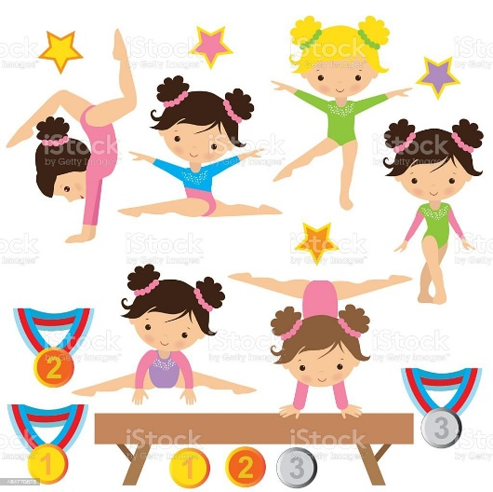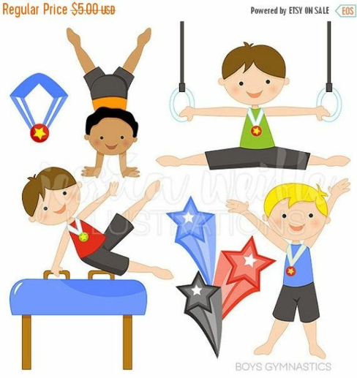

Congratulations to the Year 3 / 4 boys and girls for their fabulous performance at St Helens Gymnastics Centre. You showed great team spirit and represented your school very well in the gymnastics competition.

Your group dance was amazing and you all performed brilliantly in your individual routines. Well done!

Special thanks to Miss Bennett for her coaching, patience and enthusiasm!

