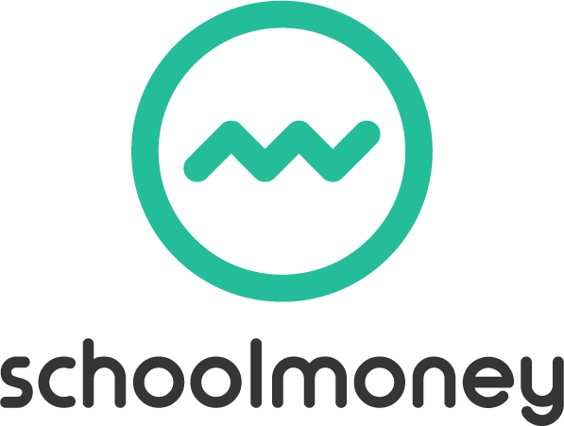

Dear Parents,
We are delighted to inform you that we have recently signed up to the online payment system SchoolMoney. This means that you will now have the facility to make payments for school expenses, such as dinner money and trips, online with your debit or credit card.
This new payment system will benefit both us as a school and you as a parent. Not only will you be able to pay for items from the comfort of your own home but you will also be able to access your account at any time to see if there is anything you need to pay for. SchoolMoney will enable us to experience a more streamlined, cost-effective and efficient payment system in a secure and safe environment.
You won’t need to sign up to this system as this is done automatically through the school and as long as you have provided us with up to date contact details we will send you a password within the next few days. This password will give you access to your SchoolMoney account where you can pay for any items we have requested from you.
To log into SchoolMoney, visit the website www.eduspot.co.uk and click on the sign in button in the top right hand corner. In the drop down, select the SchoolMoney Parent Login option and this will send you through to a page where you need to enter your mobile number, email address, the password we have sent to you, and your child’s first name.

If for any reason you are struggling to log in, it may be because you have not provided us with the correct contact details. Please let us know immediately if either your mobile number or email address changes.
We appreciate your cooperation in the early stages of rolling this system out to you.

