St Julie Catholic Primary School – Science
Topic: Animals including humans. | Year: 6 | Strand: Biology
What will I learn during this topic?
- What are the names of the main parts of the human circulatory system?
- How do our hearts work?
- Why do we need blood & how does it move oxygen around?
- How are nutrients & water transported within animals & humans?
- How does exercise affect our heart rate?
- Why is a healthy lifestyle important?
- What are medicines & drugs?
- How have ideas of the body changed over time?
Scientists 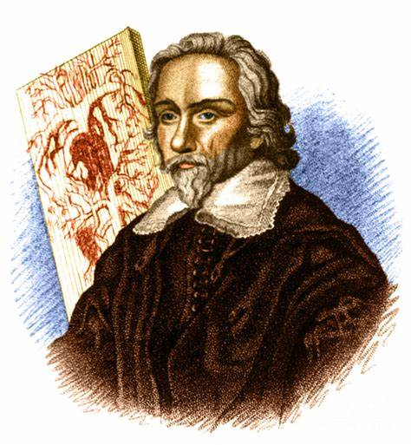
William Harvey
Justus Von Liebig
What should I already know?
- Describe the changes as humans develop into old age.
- Know the life cycles of different living things.
- Know the differences between different life cycles.
- Know the process of reproduction in plants & animals.
Scientific skills
- Describing scientific evidence about parts of the circulatory system.
- Reasoning & explaining scientific evidence about how our heart functions.
- Analysing & interpreting data – a healthy lifestyle.
Vocabulary
Oxygenated/  Deoxygenated | Supplied, treated enriched with or without oxygen.
Respiration | The movement of oxygen from the outside environment to the cells within tissues, and the removal of carbon dioxide.
Circulatory  System | A system of organs that includes the heart, blood vessels, and blood which is circulated throughout the entire body of a human or other vertebrate.
Artery | Muscular-walled tubes forming part of the circulation system by which oxygenated blood is transported from the heart.
Vein | Tubes carrying deoxygenated blood from the heart.
Transport | Fluid that transports oxygen and nutrients to the cells and carries away carbon dioxide and other waste products.

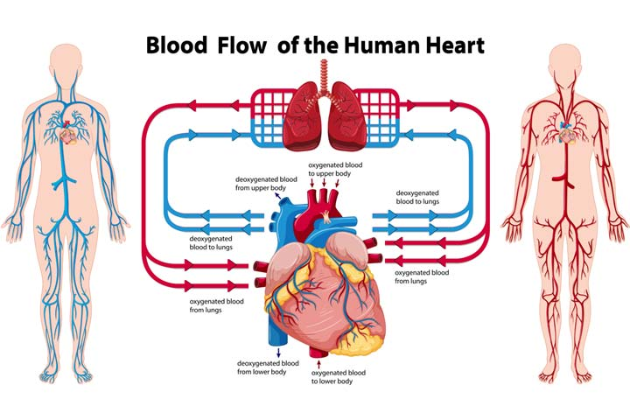
Substantive Knowledge
- Identify & name parts of the circulatory system.
- Describe the functions of the heart.
- Describe the ways nutrients & water are transported within animals & humans.
- Oxygen is breathed into lungs where it is absorbed by the blood.
- Muscles need oxygen to release energy from food to function.
- Recognise the impact of diet & exercise.

