St Julie Catholic Primary School – Science: How can you light up your life?
Topic: Light | Year: 6 | Strand: Physics
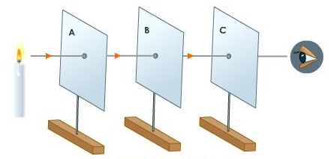
What I will learn in this topic:
1.Light appears to travel in straight lines, and we see objects when light from them goes into our eyes.
2.The light may come directly from light sources, but for other objects some light must be reflected from the object into our eyes for the object to be seen.
3.Objects that block light (are not fully transparent) will cause shadows.
4. That periscopes work because light can be reflected and travels in straight lines.
5. That prisms can split white light the 7 colours as it comes out the other side of the object.
What should I already know?
1.That light is needed in order to see things and that dark is the absence of light.
2.That light is reflected from surfaces.
3.That light from the sun can be dangerous and that there are ways to protect eyes.
4.That shadows are formed when the light from a light source is blocked by a solid object.

Significant scientist
Abu Ali al-Hasan (965-1040)
Alhazan was an Iranian
mathematician, astronomer and
physicist. He carried out
experiments with pinhole cameras
and explained how the image is
formed by rays of light travelling
in straight lines.

We can use an arrow to represent the path of the light.
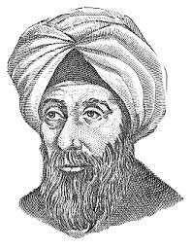
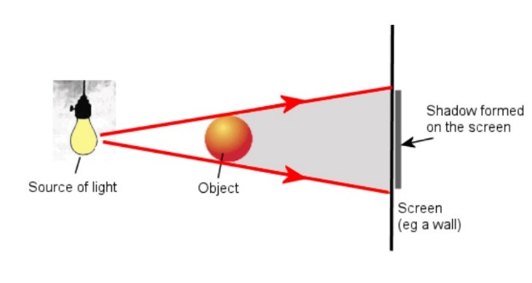
Sticky Knowledge
- I know that Light travels in straight lines
- I know that animals see light sources when light travels from the source into their eyes.
- I know that animals see objects when light is reflected off that object and enters their eyes.
- I know that light reflects off all objects (unless they are black).
- I know that non shiny surfaces scatter the light so we don’t see the beam.
- I know that light travels in straight lines the shape of the shadow will be the same as the outline shape of the object because light travels in straight lines
Light travelling in a straight line.
Opaque object blocking the light.
Scientific skills
- I can plan using scientific language.
- I can enquire & test for a light investigation.
- I can observe & record data over time.
- I can evaluate and make reasoned suggestions to improve my methods.
Vocabulary
Transparent | Light completely passes through it, and you can see clearly through it.
Translucent | Translucent objects allow some light to travel through them.
Opaque | An opaque object does not allow any light to pass through it.
Reflection | Reflection is when light bounces off an object.
Lux | A unit of illuminance, equal to one lumen per square metre.
Refraction | The change in direction of a light wave.

