St Julie Catholic Primary School – Science
Topic: What is evolution & inheritance? | Year: 6 | Strand: Biology
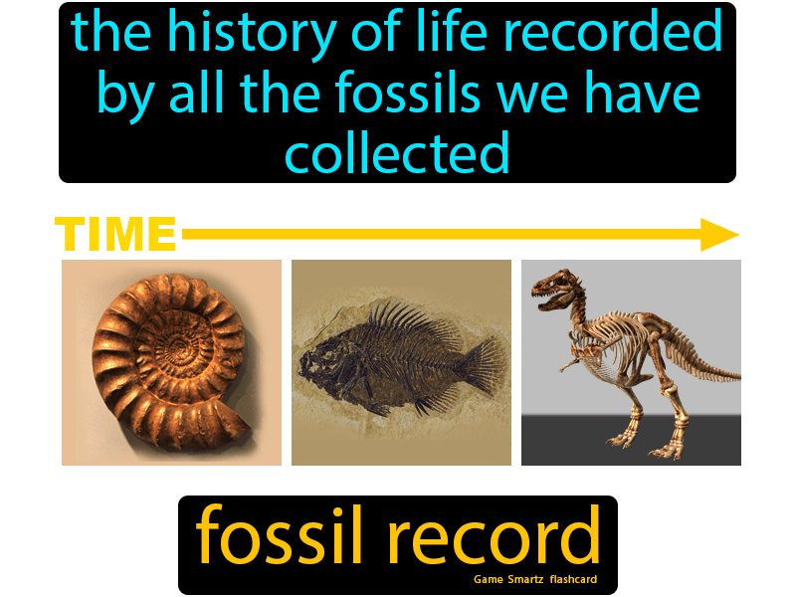
Sticky Knowledge
- To describe how plants & animals evolve
- To identify scientific theories
- To explain how to investigate genetic characteristics
- To know how to draw charts or diagrams as a result of an investigation
- To explain how a fossil is formed

What will I learn during this topic?
- I can recognise scientific ideas about evolution & inheritance.
- I can recognise the work of Charles Darwin.
- I can explain how species evolve.
- I can investigate evolution & natural selection in plants or animals.
- I can explore genetics.
- I can plan an investigation.
- I can explore the use of cladograms in an investigation.
- I can explain how fossils are formed.

Vocabulary
Evolution | Biological evolution is a scientific explanation for why there are so many different kinds of organisms on Earth and gives an account of their similarities and differences.
Inheritance | Is the process by which genetic information is passed on from parent to child. This is why members of the same family tend to have similar characteristics.
Natural selection | Natural selection is the process where organisms with favourable genes are more likely to reproduce. In doing so, they pass on these genes to the next generation.
Genetics | Is a branch of biology concerned with the study of genes, genetic variation, and heredity in organisms.
Fossils | Are the mineralized or otherwise preserved remains or traces of organisms.

What should I already know?
- describe the changes as humans develop to old age.
- describe in simple terms how fossils are formed when things that have lived are trapped within rock
Scientific skills
- Planning investigations & taking measurements, using a range of scientific equipment, with increasing accuracy and precision, taking repeat readings when appropriate
- recognise that living things have changed over time and that fossils provide information about living things that inhabited the Earth millions of years ago

