St Julie Catholic Primary School – Science
Topic: Living things & their habitats | Year: 6 | Strand: Biology
Scientific skills
- describe how living things are classified into broad groups according to common observable characteristics and based on similarities and differences, including microorganisms, plants and animals
- give reasons for classifying plants and animals based on specific characteristics.
What should I already know?
- describe the differences in the life cycles of a mammal, an amphibian, an insect and a bird
- describe the life process of reproduction in some plants and animals
- recognise that living things can be grouped in a variety of ways
What will I learn during this topic?
- Who was Carl Linnaeus and why was his work important for Scientists?
- How would you make a classification key for vertebrates/invertebrates?
- How would you make a classification key for plants and microorganisms?
- What do different types of microorganisms do? Are they always harmful?
- What happens to a piece of bread if you leave it on a windowsill for two weeks?
- How can I classify plants in the school grounds?
- How can we classify more unusual life forms?
Vocabulary
Adaptation  (how a plant/animals changes to the conditions of the habitats in which they live) | The three basic types of adaptations, based on how the genetic changes are expressed, are structural, physiological and behavioural adaptations. Most organisms have combinations of all these types.
classification | The arrangement of animals and plants in taxonomic groups according to their observed similarities.
morphology | The study of the form and structure of organisms and their specific structural features.
organism | An individual animal, plant, or single-celled life form.
Micro-organism | A small organism you can only see through a microscope.
Linnaean  (Carl Linnaeus) | Classification living organisms into groups depending on their structure and characteristics.

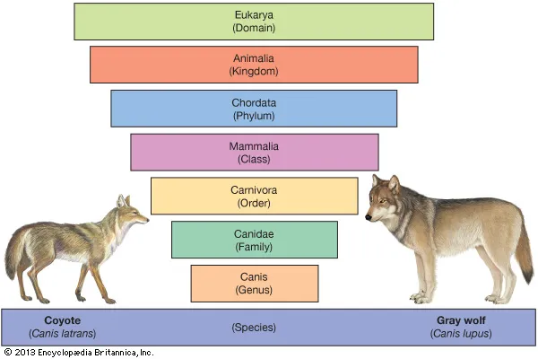
Sticky Knowledge
- To describe plant & animal habitats & how they are best suited to their environments.
- To identify characteristics of plants & animals (similarities & differences).
- To understand how living things are classified or grouped.
- To understand branching diagrams, keys, food chains and food webs.
- Variation exists within a population.

